My **Superhero** name is

**Sustainability Superhero**

Welcome to the League of Sustainability Superheroes!

Design your cape.

Your cape should show:

* A problem you are going to solve.
* The STEM career you will use to solve the problem.
* Special powers (STEM sills) you will need to solve the problem.

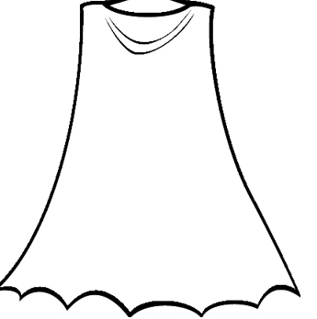

**Saving the Planet is S.T.E.M.**

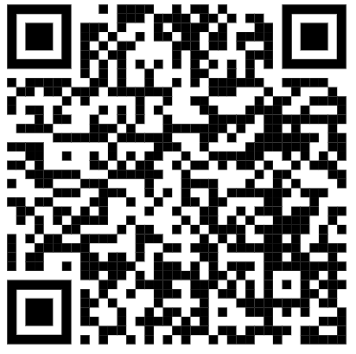

**Sustainability Superheroes**

**Saving the Planet is S.T.E.M.**

**SustainabilitySuperheroes.org**

**University of South Florida**

Gus A. Stavros Center for Free Enterprise and Economic Education

|  |  |  |  |
| --- | --- | --- | --- |
| Resource Title | How to use in MY class | Materials Needed | Notes: |
|  |  |  |  |
|  |  |  |  |
|  |  |  |  |
|  |  |  |  |