Terrific Toy Company
Based on CPALMS Resource ID#: 51194

Subject(s): Science, English Language Arts,
Grade Level(s): 1
Intended Audience: Educators
Suggested Technology: Document Camera, LCD Projector
Instructional Time: 3 Hour(s)
Resource supports reading in content area: Yes
Freely Available: Yes
Keywords: properties of matter, sorting

SC.1.P.8.1 :Sort objects by observable properties, such as size, shape, color, temperature (hot or cold), weight (heavy or light), texture, and whether objects sink or float.

LAFS.1.SL.1.1 :Participate in collaborative conversations with diverse partners about grade 1 topics and texts with peers and adults in small and larger groups.
Follow agreed-upon rules for discussions (e.g., listening to others with care, speaking one at a time about the topics and texts under discussion).
Build on others’ talk in conversations by responding to the comments of others through multiple exchanges.
Ask questions to clear up any confusion about the topics and texts under discussion.

LAFS.1.SL.1.2 :Ask and answer questions about key details in a text read aloud or information presented orally or through other media.

LESSON CONTENT

Lesson Plan Template: Model Eliciting Activity (MEA)

Formative Assessment
After the teacher reads the first client letter to the students (Reading Passage 1), the teacher will use the Readiness Questions and Comprehension Questions as a formative assessment.

Feedback to Students
Students will receive feedback throughout the lesson. The teacher will introduce the lesson and the students will work in small groups to accomplish the first task. While students are working in groups, the teacher will circulate among the groups and ask the reflective questions to each group. The teacher will give specific feedback to each group regarding their process.

Summative Assessment
The teacher will use the attached rubric to assess the students' learning using the second letter template.
Students may use the student rubric as a tool for self-assessment.

Learning Objectives
The students will:
Collaborate with their group to complete the MEA.
Sort toys by observable properties, such as size, shape, and color.
Answer questions about the key details in text.
Present their procedure and reasoning.

Prior Knowledge
Students need to know the properties of matter.
Instructional Suggestions

Part 1
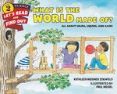
Let's-Read-and-Find-Out Science 2
What Is the World Made Of?
All About Solids, Liquids, and Gases
by Kathleen Weidner Zoehfeld, illustrated by Paul Meisel

Read the book What is the World Made Of? by Kathleen Weidner Zoehfeld or other appropriate text that explains what matter is and what properties of matter are. Ask students to name some of the properties of matter. (students should say hard/soft, color, shape, size, texture, solid/liquid/gas)

Pair up students, give each pair a group of objects to sort. (examples: unifix cube, eraser, crayon, small ball, toy car, pattern block, counter, small book, etc., or give them attribute blocks) Tell students they will work with their partner to come up with a way to sort the objects.

The teacher will circulate among the students and ask them:
How are you sorting your objects?
Is there another way you can sort them?
Lead a group discussion about the different ways the objects were sorted. Ask each group to share with the class how they sorted their objects.
Make a list on the board or chart paper of the ways the students sorted their objects.

Part 2
The teacher displays and reads aloud a copy of the first client letter (Reading Passage 1).

Reading Passage 1/Client Letter 1

Dear Students,

I am the president of the Terrific Toy Company and I need your help. Our company is launching a new line of Value Pack Toys. These value packs include several similar toys. We need your help with deciding which toys go in each pack. We plan to put 3- 4 toys in each pack. We would like you to look at the data table and the pictures of the toys and develop a plan to sort them into groups using one or more observable properties. We would like you to create 3 example value packs. You do not have to use all of the toys in the packs.
In your letter to us please tell us your plan for sorting the toys and attach your three example packs.

Thank you for your help.
Sincerely,
Mrs. I. M. Fun
President
Terrific Toy Company

Lead a class discussion focused on clarifying vocabulary the students do not understand.
Distribute data set 1, picture sheet 1, recording sheet 1. (Each group will get the data set sheet and the picture sheet.) [Teacher tip: cut out the pictures and put them into an envelope or baggie for each group before teaching this lesson.]
The teacher will ask the readiness/comprehension questions (see Readiness questions) to the class.
Have students spend 3-4 minutes independently brainstorming ways to solve the client's problem.
After students understand the task, put them in groups of 3-4 students and they can begin to work.
Students will sort the objects into groups, with 4 toys in each group.
In teams, students work on the problem and respond to the client using the letter 1 template and the recording sheet 1.
As students are working, the teacher circulates to each team to ask the first set of Guiding/Reflective Questions and address any issues that may arise. Teachers can provide guidance using the reflective questions to help students determine the important factors and start thinking about how they can present their solution.

Part 3

The teacher displays and reads aloud a copy of client letter 2 (Reading Passage 2), and distributes data set 2 and picture sheet 2, along with student work from part 1.

Teams test, evaluate, and revise their first procedure as necessary with the second data set and respond to the client using the letter 2 template and the new recording sheet 2.
As students are working, the teacher circulates to each team to ask the Reflective Questions 2 (see Reflective Questions 2 below) and addresses any issues that may arise. Teachers may provide guidance using the questions to help students determine the important factors and start thinking about how they may need to change their procedures.
As teams finish, have students use the self-assessment rubric to assess their work.
After all teams have completed their second letters to the client, the teams will present their results to the rest of the class.

Supplemental Reading
What is the World Made Of? by Kathleen Weidner Zoehfeld, student textbook, or other grade level appropriate text about properties of matter.

Guiding/Reflective Questions
How are you sorting/grouping the toys?
How do you know if you have an answer to the problem?
Do you agree with your teammates' ideas? Why or why not?
Is there another way you could sort/group the toy?
Why did you choose to sort the toys this way?
Which properties did you use to help you sort the toys? Why did you use these properties?

Readiness Questions
What is the problem? (Sort the toys to make value packs)
Who is the client? (Terrific Toy Company)
What is the client asking your team to do? (Come up with a way to sort/group the toys into value packs with four toys in each pack)
What things do you need to include in your solution? (Need to have the toys sorted into groups of four toys and how the toys were sorted)
Do you think there is more than one correct answer to what the client is asking? Why or why not?

Reflection questions 2
Did you need to change your procedure for sorting the toys?
If you changed your procedure, how did you change your procedure?
Did you use more than one strategy or plan to help you sort the toys?
Are each of the value packs 10 points or less?
Additional Instructions or Materials
A set of six objects or attribute blocks for pairs of students to sort. Examples - unifix cubes, counters, pattern blocks, toy car, small ball, crayon, eraser, book, small stuffed animal
What is the World Made Of? by Kathleen Weidner Zoehfeld
Picture credits

PBS Kids game to sort objects by an observable property: http://pbskids.org/sid/fablab_sortingbox.html

Accommodations:
Name the pictures in the data set for ESL students.
Students with poor fine motor skills may need specialty scissors to help with the cutting of the pictures. Or, group these students with students who can help them with the cutting and pasting.

Extensions: Students can revisit the book What is the World Made of? by Kathleen Weidner Zoehfeld and do the experiments on the inside cover of the book.

Terrific Toy Company Rubric

Student Name: ________________________________________
CATEGORY |  | 4 | 3 | 2 | 1
Working with Others |  | Student was an engaged team member, listening to suggestions of others and working cooperatively throughout lesson. | Student was an engaged team member but had trouble listening to others and/or working cooperatively. | Student cooperated with others, but needed prompting to stay on-task. | Student did not work effectively with others.
Strategy/Procedures |  | Typically, uses an efficient and effective strategy to solve the problem(s). | Typically, uses an effective strategy to solve the problem(s). | Sometimes uses an effective strategy to solve problems, but does not do it consistently. | Rarely uses an effective strategy to solve problems.
Explanation |  | Explanation is detailed and clear. | Explanation is clear. | Explanation is a little difficult to understand, but includes critical components. | Explanation is difficult to understand and is missing several components OR was not included.
Presentation |  | Presented a clear explanation of plan including how toys were grouped. | Presented an explanation of plan, may have left out a part. | Presented an explanation that included some parts of the plan. | Did not present an explanation of plan.

Terrific Toy Company
Self Assessment
Team Name _______________
Did we: | ☺ | ☹
Sort the toys into groups?
Do our toys add up to 10 points or less?
Give reasons why?
Take turns talking?
Write our plan neatly?

Terrific Toy Company
Self-Assessment Team Name _______________
Did we: | ☺ | ☹
Sort the toys into groups?
Do our toys add up to 10 points or less?
Give reasons why?
Take turns talking?
Write our plan neatly?

Reading Passage 1/Client Letter 1

Dear Students,

I am the president of the Terrific Toy Company and I need your help. Our company is launching a new line of Value Pack Toys. These value packs include several similar toys. We need your help with deciding which toys go in each pack. We plan to put 3- 4 toys in each pack. We would like you to look at the data table and the pictures of the toys and develop a plan to sort them into groups using one or more observable properties. We would like you to create 3 example value packs. You do not have to use all of the toys in the packs.
In your letter to us please tell us your plan for sorting the toys and attach your three example packs.

Thank you for your help.
Sincerely,
Mrs. I. M. Fun
President
Terrific Toy Company

Terrific Toy Picture Page 1

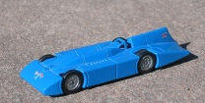 | 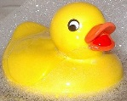 | 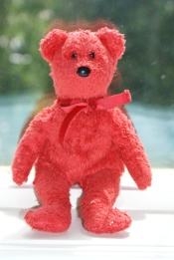
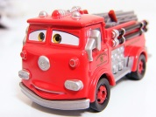 | 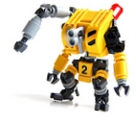 | 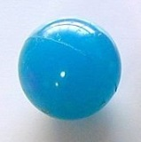
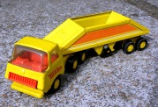 | 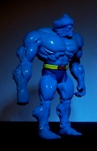 | 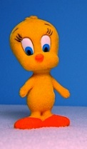
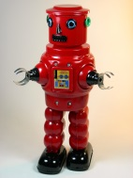 | 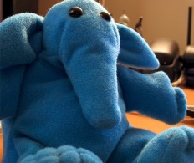 | 

Terrific Toy Company (Data Set 1)
Toy | Moveable parts? | Made of | Color | Hard/ Soft
 | yes | metal | blue | hard
 | no | rubber | yellow | soft
 | no | cloth | red | soft
 | yes | metal | red | hard
 | yes | plastic | yellow | hard
 | no | rubber | blue | soft
 | yes | metal | yellow | hard
 | yes | plastic | blue | hard
 | no | cloth | yellow | soft
 | yes | plastic | red | hard
 | no | cloth | blue | soft
 | no | rubber | red | soft

Team Name ___________

Value Pack 1 | Value Pack 2 | Value Pack 3

Student Letter Template 1
Dear Terrific Toy Company,

Our team, __________________, has decided the best way to sort the toys is by:

______________________________________
______________________________________

The toys in Value Pack 1 are _____________________________________.
The toys in Value Pack 2 are _____________________________________.

The toys in Value Pack 3 are _____________________________________.

Sincerely,

______________________

Client Letter/Reading Passage 2
Dear students,

Thank you for your hard work in figuring out how to sort the toys for our Value Packs. We need to keep the cost of each pack low. So, we have added a point value to each toy. We need each pack not to exceed 10 points. Also, we found some new toys to add to the packs. I have included pictures with the new toys added. Please look at the new set of data, the pictures and make any changes needed to your plan so that we have 3-4 toys in each pack. Remember to explain your process for sorting the toys and attach your 3 value packs to your letter. Thank you for your time and we look forward to hearing from you.

Thank you for your help.
Sincerely,
Mrs. I. M. Fun
President
Terrific Toy Company

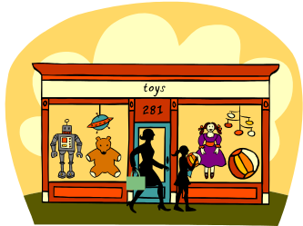

Terrific Toy
Picture Page 2

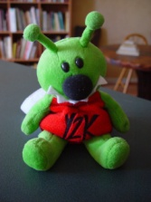 | 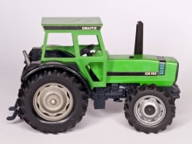

Terrific Toy Company (Data set 2)
Toy | Moveable parts? | Made of | Color | Hard/ Soft | Point value
 | yes | metal | blue | hard | 2
 | no | rubber | yellow | soft | 3
 | no | plastic | red | soft | 4
 | yes | metal | red | hard | 4
 | yes | plastic | yellow | hard | 3
 | no | rubber | blue | soft | 2
Toy | Moveable parts? | Made of | Color | Hard/ Soft | Point value
 | yes | metal | yellow | hard | 3
 | yes | plastic | blue | hard | 2
 | no | cloth | yellow | soft | 3
 | yes | plastic | red | hard | 4
 | no | cloth | blue | soft | 2
 | no | rubber | red | soft | 4
 | no | cloth | green | soft | 1
 | yes | metal | green | hard | 1
Sorting page
Team Name ___________

Value Pack 1 | Value Pack 2 | Value Pack 3
Student Letter Template 2
Dear Terrific Toy Company,

Our team, __________________, has decided the best way to sort the toys is by:
______________________________________
______________________________________
____________________________________________________________________________

The way we sorted the toys (did/ did not) change. (If it changed, explain how and why. If it did not change, explain why not).
____________________________________________________________________________
The toys in Value Pack 1 are _____________________________________.
The toys in Value Pack 2 are___________________________________.

The toys in Value Pack 3 are___________________________________.

Sincerely,
______________________

Reading Passage 1/Client Letter 1 Angel Tree Version

Dear Students,

I am an Angel Tree volunteer and I need your help. We are making toy packs to give to children as holiday gifts. These toy packs include several similar toys. We need your help with deciding which toys go in each pack. We plan to put 3 toys in each pack. We would like you to look at the data table and the pictures of the toys and develop a plan to sort them into groups using one or more observable properties. We would like you to create 3 example value packs. You do not have to use all of the toys in the packs.
In your letter to us please tell us your plan for sorting the toys and attach your three example packs.

Thank you for your help.
Sincerely,
Mrs. I. M. Fun
Volunteer
Angel Tree

Dear Mr. Fun,

Our team, __________________, has decided the best way to sort the toys is by:

______________________________________
______________________________________

The toys in Value Pack 1 are _____________________________________.
The toys in Value Pack 2 are _____________________________________.

The toys in Value Pack 3 are _____________________________________.

Sincerely,

______________________

