Ozone Layer Definition
“The ozone layer is a region in the earth’s stratosphere that contains high concentrations of ozone and protects the earth from the harmful ultraviolet radiations of the sun.”
Table of Contents
- What is an Ozone Layer?
- Ozone Layer Depletion
- What is Ozone Layer Depletion?
- Causes of Ozone Layer Depletion
- Ozone Depleting Substances (ODS)
- Effects Of Ozone Layer Depletion
- Solutions to Ozone Layer Depletion

What is an Ozone Layer?
The ozone layer is mainly found in the lower portion of the earth’s atmosphere. It has the potential to absorb around 97-99% of the harmful ultraviolet radiations coming from the sun that can damage life on earth. If the ozone layer was absent, millions of people would develop skin diseases and may have weakened immune systems.
However, scientists have discovered a hole in the ozone layer over Antarctica. This has focused their concern on various environmental issues and steps to control them. The main reasons for the ozone hole are chlorofluorocarbons, carbon tetrachloride, methyl bromide and hydrochlorofluorocarbons.

Ozone Layer Depletion
“Ozone layer depletion is the gradual thinning of the earth’s ozone layer in the upper atmosphere caused due to the release of chemical compounds containing gaseous bromine or chlorine from industries or other human activities.”
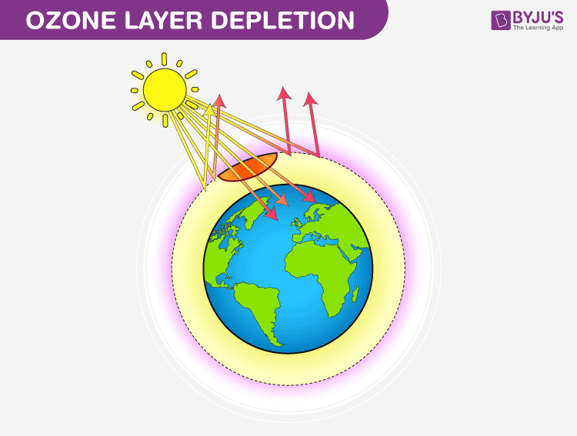

What is Ozone Layer Depletion?
Ozone layer depletion is the thinning of the ozone layer present in the upper atmosphere. This happens when the chlorine and bromine atoms in the atmosphere come in contact with ozone and destroy the ozone molecules. One chlorine can destroy 100,000 molecules of ozone. It is destroyed more quickly than it is created.
Some compounds release chlorine and bromine on exposure to high ultraviolet light, which then contributes to ozone layer depletion. Such compounds are known as Ozone Depleting Substances (ODS).
The ozone-depleting substances that contain chlorine include chlorofluorocarbon, carbon tetrachloride, hydrochlorofluorocarbons, and methyl chloroform. Whereas, the ozone-depleting substances that contain bromine are halons, methyl bromide, and hydro bromofluorocarbons.
Chlorofluorocarbons are the most abundant ozone-depleting substance. It is only when the chlorine atom reacts with some other molecule, it does not react with ozone.
Montreal Protocol was proposed in 1987 to stop the use, production and import of ozone-depleting substances and minimise their concentration in the atmosphere to protect the ozone layer of the earth.

Causes of Ozone Layer Depletion
Ozone layer depletion is a major concern and is associated with a number of factors. The main causes responsible for the depletion of the ozone layer are listed below:

Chlorofluorocarbons
Chlorofluorocarbons or CFCs are the main cause of ozone layer depletion. These are released by solvents, spray aerosols, refrigerators, air-conditioners, etc.
The molecules of chlorofluorocarbons in the stratosphere are broken down by ultraviolet radiations and release chlorine atoms. These atoms react with ozone and destroy it.

Unregulated Rocket Launches
Researches say that the unregulated launching of rockets results in much more depletion of the ozone layer than the CFCs do. If not controlled, this might result in a huge loss of the ozone layer by the year 2050.

Nitrogenous Compounds
The nitrogenous compounds such as NO₂, NO, N₂O are highly responsible for the depletion of the ozone layer.

Natural Causes
The ozone layer has been found to be depleted by certain natural processes such as Sun-spots and stratospheric winds. But it does not cause more than 1-2% of the ozone layer depletion.
The volcanic eruptions are also responsible for the depletion of the ozone layer.

Ozone Depleting Substances (ODS)
“Ozone-depleting substances are the substances such as chlorofluorocarbons, halons, carbon tetrachloride, hydrofluorocarbons, etc. that are responsible for the depletion of the ozone layer.”
Following is the list of some main ozone-depleting substances and the sources from where they are released:
Ozone-Depleting Substances | Sources
Chlorofluorocarbons (CFCs) | Refrigerators, air-conditioners, solvents, dry-cleaning agents, etc.
Halons | Fire-extinguishers
Carbon tetrachloride | Fire extinguishers, solvents
Methyl chloroform | Adhesives, aerosols
Hydrofluorocarbons | fire extinguishers, air-conditioners, solvents
Also Read: Global Warming

Effects Of Ozone Layer Depletion
The depletion of the ozone layer has harmful effects on the environment. Let us see the major effects of ozone layer depletion on man and environment.

Effects on Human Health
Humans will be directly exposed to the harmful ultraviolet radiation of the sun due to the depletion of the ozone layer. This might result in serious health issues among humans, such as skin diseases, cancer, sunburns, cataract, quick ageing and weak immune system.

Effects on Animals
Direct exposure to ultraviolet radiations leads to skin and eye cancer in animals.

Effects on the Environment
Strong ultraviolet rays may lead to minimal growth, flowering and photosynthesis in plants. The forests also have to bear the harmful effects of the ultraviolet rays.

Effects on Marine Life
Planktons are greatly affected by the exposure to harmful ultraviolet rays. These are higher in the aquatic food chain. If the planktons are destroyed, the organisms present in the food chain are also affected.

Solutions to Ozone Layer Depletion
The depletion of the ozone layer is a serious issue and various programmes have been launched by the government of various countries to prevent it. However, steps should be taken at the individual level as well to prevent the depletion of the ozone layer.
Following are some points that would help in preventing this problem at a global level:

Avoid Using ODS
Reduce the use of ozone depleting substances. E.g. avoid the use of CFCs in refrigerators and air conditioners, replacing the halon based fire extinguishers, etc.

Minimise the Use of Vehicles
The vehicles emit a large amount of greenhouse gases that lead to global warming as well as ozone depletion. Therefore, the use of vehicles should be minimised as much as possible.

Use Eco-friendly Cleaning Products
Most of the cleaning products have chlorine and bromine releasing chemicals that find a way into the atmosphere and affect the ozone layer. These should be substituted with natural products to protect the environment.

Use of Nitrous Oxide should be Prohibited
The government should take actions and prohibit the use of harmful nitrous oxide that is adversely affecting the ozone layer. People should be made aware of the harmful effects of nitrous oxide and the products emitting the gas so that its use is minimised at the individual level as well.
Also Read: Our Environment

Frequently Asked Questions
Q1

What is ozone layer depletion? How does it occur?
The thinning of the ozone layer present in the upper atmosphere is called ozone layer depletion. Some chemical compounds release chlorine and bromine, which in exposure to high ultraviolet light causes the depletion of ozone.
Q2

What are ozone-depleting substances? Give examples.
The chemical substances which are responsible for depletion of the earth’s protective ozone layer are called ozone-depleting substances (ODS). Examples are halons, chlorofluorocarbons, hydrofluorocarbons, carbon tetrachloride etc.
Q3

What is the main aim of the Montreal Protocol?
The Montreal Protocol is a global agreement which was proposed in the year 1987. The agreement focuses on protecting the ozone layer by minimising the production and consumption of ozone-depleting substances.
Q4

What are the effects of ozone layer depletion on human health?
Ozone layer helps in shielding the harmful ultraviolet rays of the sun. Depletion of the ozone layer exposes humans to harmful ultraviolet rays, this causes skin diseases, cataract, cancer, impaired immune system etc.
For more detailed information on the ozone layer, ozone layer depletion, causes, effects and solutions to ozone layer depletion, keep visiting BYJU’S website or download the BYJU’S app for further reference.

