America's new normal: A degree hotter than two decades ago
Climate normals describe what the normal or usual climate is like in different regions. For example, some places are hot and dry. Others are cold and wet. The normals are an average of weather and climate data, or information. The data is recorded for 30 years.
Scientists collect weather data at weather stations. Weather is the events happening in the atmosphere. It is at a specific place and a particular time. Some of the data collected are air pressure, temperature, and wind speed. The stations also collect humidity information. It is the amount of water vapor in the air. The stations also collect information about precipitation. This is the rain, snow or icefall.
The National Oceanic and Atmospheric Administration (NOAA) is a U.S. science agency. It studies the oceans and the atmosphere. Every 10 years, NOAA updates normals for the U.S.
In early May 2021, NOAA released climate normals. The normals are for the years between 1991 and 2020.

Half A Degree Warmer
The new climate normals show that the temperature is hotter. The yearly normal temperature is now 11.8 degrees Celsius. That is 53.3 degrees Fahrenheit. It is half a degree hotter than 10 years ago. It is a full degree hotter than 20 years ago.
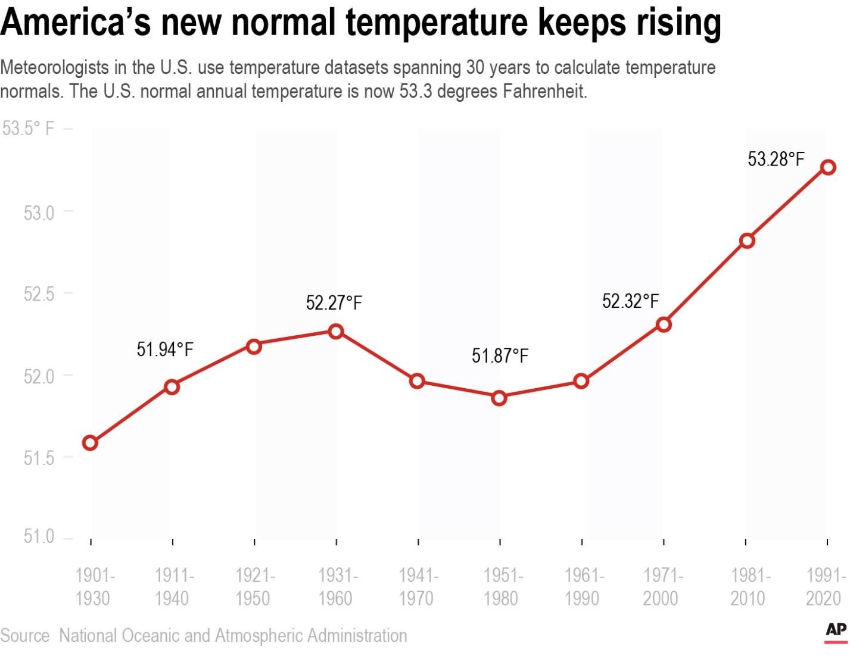
Zoom inMeteorologists in the U.S. calculated temperature normals with datasets spanning 30 years. The U.S. normal annual temperature is now 53.3 degrees Fahrenheit. Graphic: AP
The largest temperature jump was 1.02 degrees Celsius (1.5 degrees Fahrenheit). That happened in Chicago, Illinois. And it happened in Asheville, North Carolina. Other cities saw the temperature rise by only half a degree.
Overall, over 90 percent of the U.S. is warmer. But the new United States normal is not just hotter. It is also wetter in the eastern and central parts of the nation. Asheville saw a nearly 9 percent increase in rainfall. New York City's rainfall rose 6 percent.
It is drier in the West than just a decade earlier. Phoenix, Arizona had the biggest change in rain. The rainfall dropped by 10 percent. Rainfall in Los Angeles dropped by almost 5 percent.

Climate Change
Some scientists use the normals to talk about how climate change is affecting our planet. Climate change is a significant change in Earth's temperatures over a long period. It can happen naturally or by human activity. However, other scientists prefer the way NASA uses climate data. NASA describes climate using an average from 1951 to 1980.
There are other reasons that climate normals are useful. Some cities use the information to prepare for flooding or droughts. Farmers can use the data to choose what and when to plant. Some energy companies look at climate normals, too. It helps them plan how much energy people will need to heat and cool their homes.
Kathie Dello has one thing to say about the normals. She studies climate in North Carolina. Dello says that it seems odd to still call them normals. 1991-2020 was anything but normal climate-wise.
Copyright 2023 The Associated Press.

