America's new normal: A degree hotter than two decades ago
Every 10 years, the National Oceanic and Atmospheric Administration (NOAA) updates climate normals for the country as a whole, and for states and cities, too. NOAA is a U.S. science agency that focuses on the oceans and the atmosphere.
Climate normals are just that: They describe what the normal or usual climate is like in different regions of the U.S., such as hot and dry or cold and wet. Meteorologists, who are scientists who study the weather, use data, or information, calculate climate normals using data from weather stations.
Weather is the conditions in the atmosphere at a localized place and a particular time. It is usually described in terms of particular features, such as air pressure, humidity, moisture, any precipitation (rain, snow or ice), temperature and wind speed. Climate, on the other hand, is the weather patterns over a long period of time, usually 30 years or more. Calculating new normals tells scientists if regions are changing, such as getting hotter or wetter, or if areas are staying the same.
In early May 2021, NOAA released climate normals for the years 1991 to 2020. The recently released data shows that America's new normal temperature is a degree hotter than it was just two decades ago.

Half A Degree Warmer
For the entire nation, the yearly normal temperature is now 11.8 degrees Celsius (53.3 degrees Fahrenheit). It is nearly half a degree warmer than a decade ago. Twenty years ago, the normal was 11.3 degrees Celsius (52.3 degrees Fahrenheit) based on data from 1971 to 2000. The average U.S. temperature for the 20th century was 11.1 degrees Celsius (52 degrees Fahrenheit).
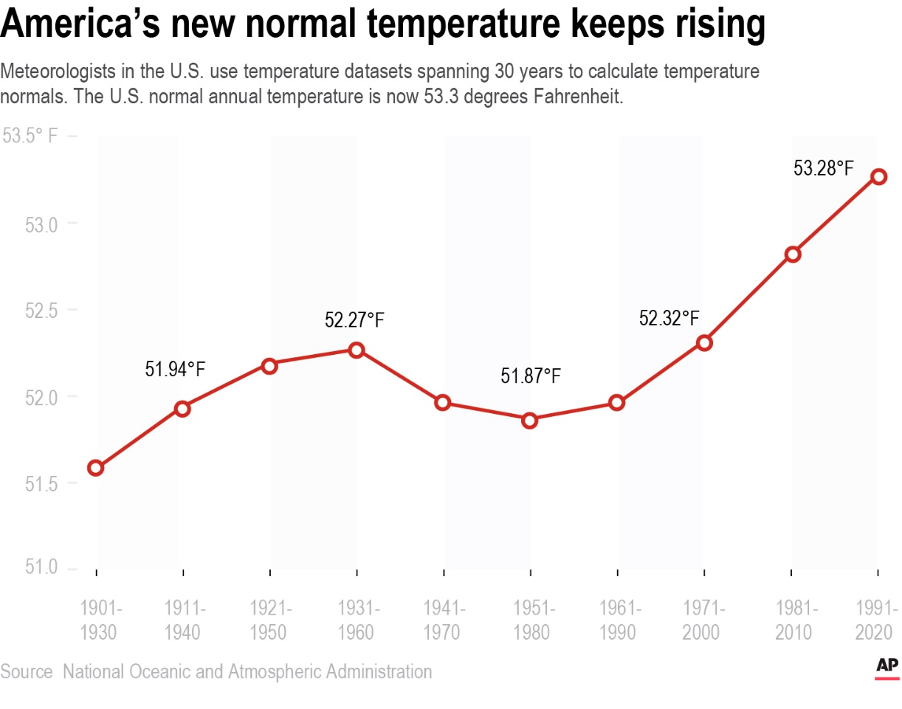
Zoom inMeteorologists in the U.S. calculated temperature normals with datasets spanning 30 years. The U.S. normal annual temperature is now 53.3 degrees Fahrenheit. Graphic: AP
The new normal annual U.S. temperature is 0.9 degrees Celsius hotter than the first normal calculated for 1901 to 1930. That is an increase of about 1.7 degrees in Fahrenheit.
More than 90 percent of the U.S. has warmer normal temperatures now than 10 years ago.In Chicago, Illinois, and Asheville, North Carolina, the new yearly normal temperature jumped 1.02 degrees Celsius (1.5 degrees Fahrenheit) in a decade. Cities like Seattle, Washington, and Atlanta, Georgia, had their normal annual temperature rise by at least half a degree. So did Boston, Massachusetts, and Phoenix, Arizona.
The new United States normal is not just hotter, but wetter in the East. Asheville saw a nearly 9 percent increase in rainfall, while New York City's rainfall rose 6 percent. Seattle's normal is 5 percent wetter than in the past.
At the same time, it is drier in the West than just a decade earlier. Phoenix, Arizona had the biggest change in rain. The normal annual rainfall dropped 10 percent down to 18.2 centimeters (7.2 inches). Rainfall in Los Angeles, California, dropped 4.6 percent.

Climate Change
Some scientists use the normals to talk about how climate change is affecting our planet. Climate change is a significant change in Earth's temperatures over a long period, caused naturally or by human activity. New normals show that the last decade was "a much hotter time period for much of the globe than the decades" before, said Natalie Mahowald, who is a climate scientist at Cornell University. However, other scientists prefer the way NASA uses climate data from 1951 to 1980.
Still, there are scientists who find the calculations useful for other reasons. Climate normals help city and regional planners to prepare for flooding and drought. Farmers can decide what and when to plant. Energy companies can try to meet changing demands, and doctors can tackle public health issues arising from climate change.
North Carolina's state climatologist Kathie Dello said, "It seems odd to still call them normals because 1991-2020 was anything but normal climate-wise."

