Massive ice loss on Greenland is now speeding up, scientists find

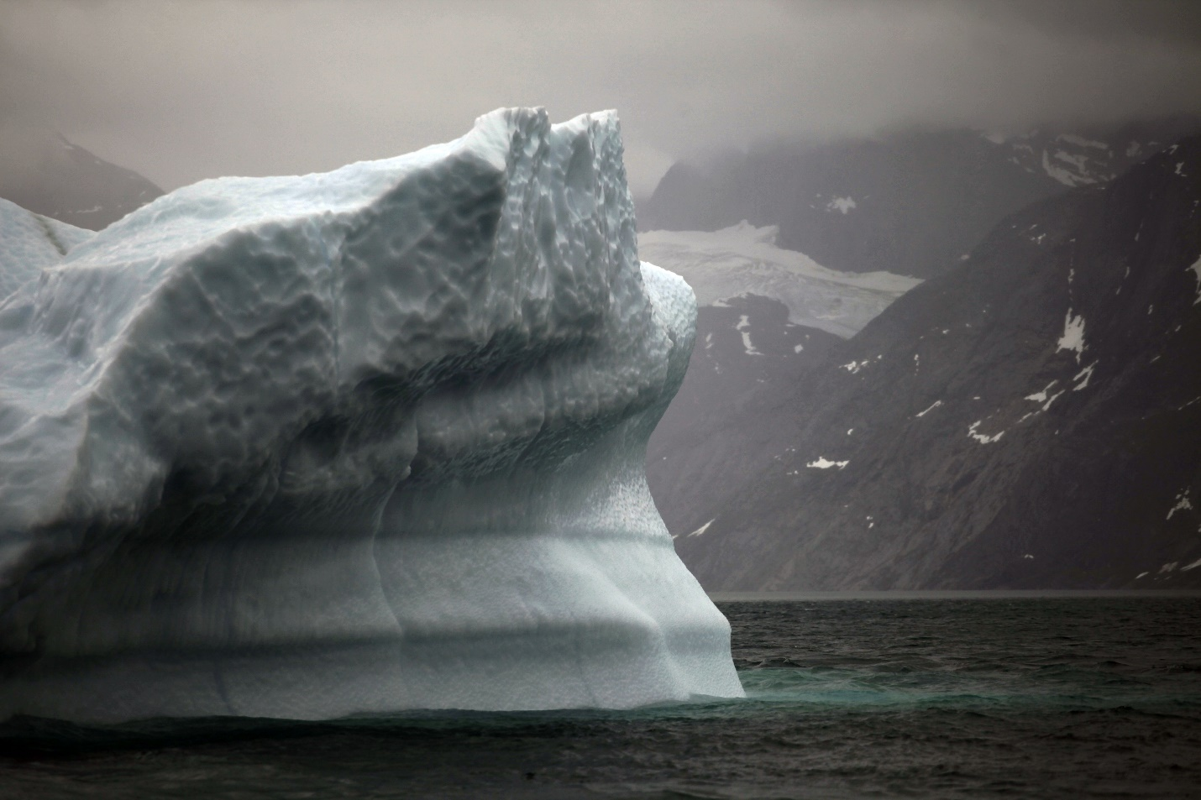A melting iceberg floats along a fjord leading away from the edge of the Greenland ice sheet near Nuuk, Greenland, July 26, 2011.
By Chris Mooney, Washington Post, The Washington Post, adapted by Newsela staff
RECOMMENDED FORMiddle School – High School
WORDS962
TEXT LEVEL9
Main Idea: The article is about a new study that has calculated the mass loss of the Greenland ice sheet since 1900, finding that it has lost 9,103 gigatons and the rate of loss has been increasing. Key Themes: * Climate Change * Ice Loss * Sea Level Rise
These suggestions have been generated by an AI model, but the ideas and underlying gist are original and generated by a human author.
A massive new study has calculated just how much ice the Greenland ice sheet has lost since the year 1900. The number is astounding: 9,103 gigatons.
A gigaton is a billion metric tons. For reference, the Statue of Liberty weighs about 200 metric tons.
The study was published in the journal Nature and was completed by 16 authors led by Kristian K. Kjeldsen of the Natural History Museum of Denmark at the University of Copenhagen.
Estimating the loss of ice was not easy and required the use of multiple information sources. These included the distinct marks left by retreating glaciers on the landscape, extensive aerial photography from 1978 through 1987, and satellite and aircraft observations beginning in 1983.
All were merged to provide the new ice loss estimates. "It's the first observational-based study that shows where Greenland has lost its mass over the last 110 years," said Kurt H. Kjær, the paper's senior author.

Greenland's Melt Affects World Over
The study offers a better understanding of how Greenland's ice loss has contributed to sea level rise. As the global temperature has gradually increased, ice in Greenland and throughout the Arctic has started to melt. The melting ice has added to the oceans' volume, causing water to creep higher onto the land.
The study also shows that the ice in Greenland is starting to melt more quickly, with the amount of annual ice loss doubling from 2003 to 2010 compared with 1983-2003. Additionally, the ice loss from 2003-2010 was double that of the loss throughout the 20th century. During the most recent period, the authors found that an average of 186 gigatons of ice melted each year, while other estimates have put that number even higher. NASA currently states that Greenland is losing 287 billion tons of ice per year.
While the pace of ice loss has recently increased, the study notes that ice melted in Greenland throughout the 20th century. The authors suggest that around 1900, the Earth started coming out of the Little Ice Age, a natural cool period, and as the planet started warming, some ice began to melt.

Human Contribution To Warming
However, the speed of ice loss increased rapidly as major human-caused global warming kicked in. Most scientists believe that the release of greenhouse gasses, caused by human activities, has led to a dangerous increase in the Earth's temperature.
Since 1900, the research finds, Greenland's major mass loss has been coming quite consistently from a few key regions. Much of the melting has come from the northwest and southeast of the ice sheet, the vast layer of ice that covers about 80 percent of Greenland. Ice has also been melting from the Jakobshavn glacier in the southwest, Greenland's single fastest moving glacier. It is currently losing 25 to 35 gigatons of ice annually.
However, in recent years, the northeast of the ice sheet has started to melt as well. It features two major glaciers named Zachariae Isstrøm and Nioghalvfjerdsfjorden, which hold back 12 percent of all of Greenland's ice.
Ice loss from Greenland today mainly occurs in two ways. Ice on the surface of the ice sheet melts, and the water runs into the ocean, and large chunks of ice, called icebergs, break off from glaciers, drifting into the sea and accelerating the melting process.

Higher Sea Levels
The new research suggests that the ice melting in Greenland has had a major impact on the rising sea level. The study estimates that 9,103 gigatons of ice have been lost from Greenland in the last 110 years. That would amount to a 2.5 centimeter of sea level rise. In other words, if the new study is correct, ice loss in Greenland has added an inch to the world's oceans.
An inch may not sound like much, but spread over the entire globe it is a staggering and dangerous amount of water. If Greenland's ice keeps melting, it could lead to disaster. Taken in total, if the Greenland ice sheet were to melt, it would lead to roughly 20 feet of sea level rise.
The study also measured the amount of fresh water that has traveled into the North Atlantic ocean from Greenland and from melting Canadian Arctic glaciers over the course of the last century. According to Jason Box, a professor with the Geological Survey of Denmark and Greenland, most of that melted water has probably stayed in the North Atlantic.
"The Gulf Stream presents a wall in the ocean south, where this fresh water just can't go. So the fresh water must be accumulating in the North Atlantic," he says.

Salt, Sea, Currents And Circulation
This could be interfering with the Atlantic Ocean's water currents and circulation, which are driven by differences in temperature and saltiness of ocean waters. Cold salty water sinks in the North Atlantic and travels southward, pulling more warm water north. If too much fresh water is added to the North Atlantic, that could slow or eventually shut down the circulation. This would have dramatic effects on the Earth's climate.
The fact that so much ice in Greenland has melted, contributing fresh water to the oceans, is troubling, and the melting appears to be speeding up. The key for the future of Greenland's ice comes down to global warming. The big question is how high global temperatures will rise and how long they will stay there.
Last month, world leaders met in Paris, France, and agreed to the goal of keeping warming well below 2 degrees Celsius (about 3.5 degrees Fahrenheit). If achieved, that may be enough to prevent all of Greenland's ice from melting.
However, if the Earth gets much warmer than that, Greenland's ice will not last. "The ice sheets are doomed in a plus-3-Celsius world," says Box.
Reproduced with permission. Copyright © 2023 Washington Post. All rights reserved.

