Hurricane Ian destroyed parts of Florida, but one town came out of the storm almost unscathed. Inside Babcock Ranch, where they survived 'by design.'
Insider Amanda Goh Feb 13, 2023
How a Solar-Powered Florida Town Survived Hurricane Ian (insider.com)
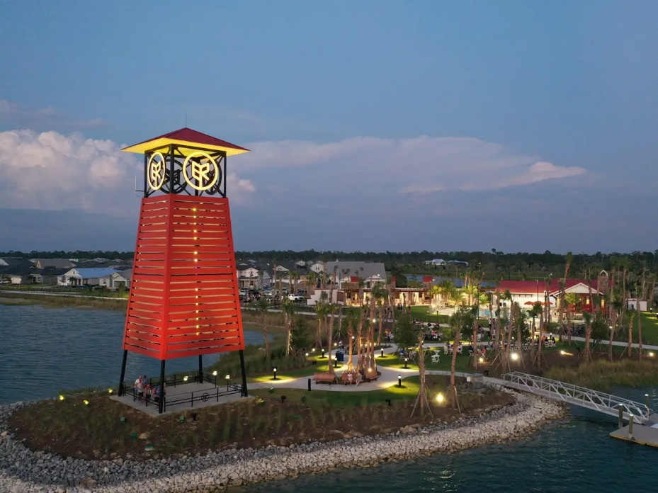
Babcock Ranch’s Innovation Tower light display, a beacon that was built to represent the town’s pledge to sustainable growth and environmental preservation.
Kitson & Partners
For all five years that he's lived in Babcock Ranch, Mark Wilkerson has been telling everyone he'll never lose power in a storm.
But when Hurricane Ian slammed into southwestern Florida in September, with its torrential rain and 150 mph winds, Wilkerson felt his conviction waver. Seated at his dining table all alone, he could feel the walls of his house shake under the sheer force of nature. "Today's the day the power is going to go out," he thought. And there was nothing he could do but wait.
But the darkness and the cold never came. The lights in his house flickered — but they never went out.
"I lost one shingle on my roof," Wilkerson told Insider.
Wilkerson is one of about 6,000 residents who live in Babcock Ranch, a solar-powered town in southwest Florida that survived Hurricane Ian with minimal damage.
Ian — the strongest hurricane to hit the state since Michael in 2018 — all but decimated Fort Myers, less than 20 miles away. Photos of the aftermath show entire neighborhoods submerged in water, roads covered in fallen trees, and boats ripped from their docks.

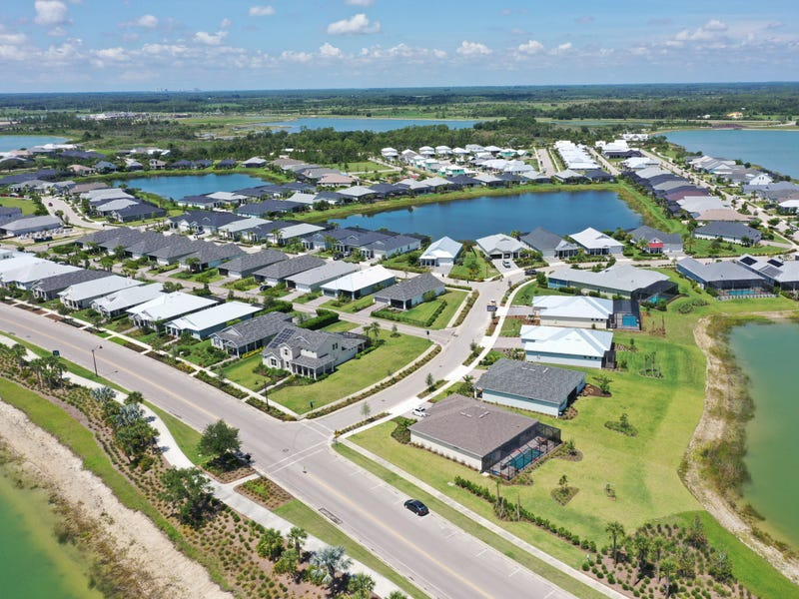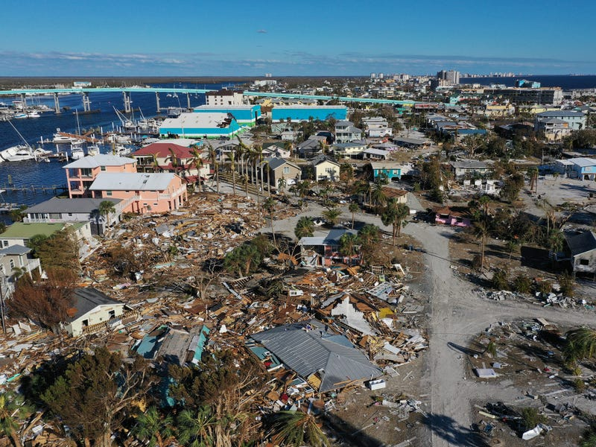
Babcock Ranch was unscathed by Hurricane Ian.
Fort Myers Beach sustained severe damage by the Category 4 Hurricane Ian. WinMcNamee/Getty Images

In all, the storm killed at least 148 people, per NBC, and caused between $50 billion and $65 billion in insured losses, per estimates from reinsurer Swiss Re.
It's been nearly five months since Ian hit, but the process of rebuilding continues. Recent photographs of Fort Meyers, taken in January by photographer Joe Raedle, show piles of debris, ongoing construction efforts, and people still living in makeshift tent homes.
In contrast, there were only a few fallen trees and some lightly damaged roofs in Babcock Ranch post-Ian. Everything else escaped virtually unscathed.
"We never lost power, water, or internet," Wilkerson said. "And it's all by design, we weren't just lucky."

Building a solar-powered town in Florida
The origins of Babcock Ranch trace back to 2006, when a football player turned real-estate developer named Syd Kitson bought a 92,000-acre land parcel in Florida for $700 million.
A day after he closed the deal, Kitson sold 74,000 acres to the state for conservation purposes and retained 17,000 acres on which his future town would sit, The New York Times reported in August 2006.
The goal, Kitson told Insider, was to create "the most environmentally responsible, the most resilient new town that's ever been built."
"What we wanted to prove was that a new town like Babcock Ranch can work hand in hand with nature," he added.
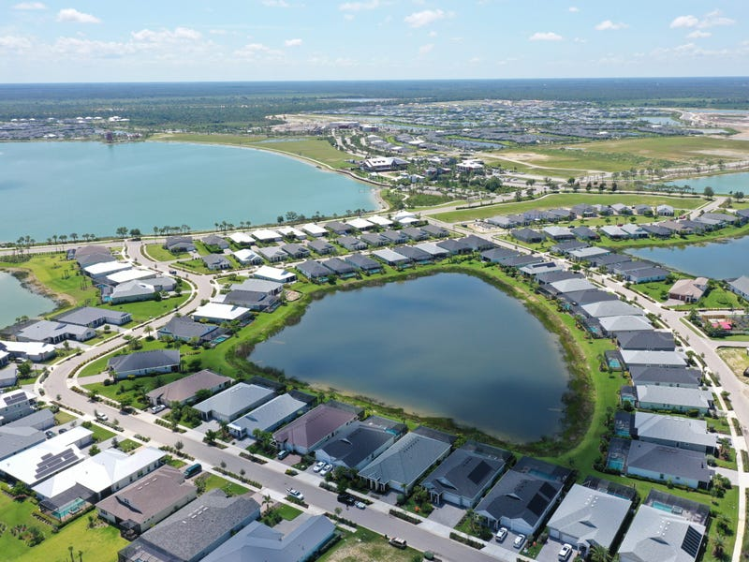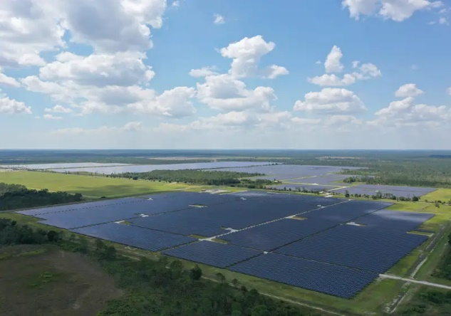
The solar farm produces enough to power almost 30,000 homes. Kitson & Partners
Small lakes around the neighborhood are designed to catch water and protect houses from flooding. Kitson & Partners

Babcock Ranch was built 30 feet above sea level and all power lines are buried underground to keep them safe from strong winds, Kitson said.
Neatly parceled homes and properties branch out from a street that meanders through the neighborhood. Houses range from two- to five-bedroom layouts and come with various levels of customization, including a backyard pool, multiple garages, and an outdoor patio.
Small lakes around the neighborhood are meant to protect houses from flooding, Wilkerson said: "If they overflow, they're intentionally designed to flood into the streets and around the houses."
And then there's the 840-acre solar farm and battery storage facility, built by the largest power utility in the state, Florida Power and Light, or FPL.
The farm has about 700,000 solar panels, per data sheets from FPL, and it can produce enough energy to power almost 30,000 homes a year.
The solar farm is what drew Wilkerson to Babcock Ranch. For years, Wilkerson and his wife, Rhonda, had been searching for a place to call home in Florida. They were living near Chicago, and they were getting sick of the cold. They knew that living in the Sunshine State meant dealing with hurricanes, but they didn't want to leave town every time a storm came in.
While they were discussing their plans in a wine bar in Orlando on a house-hunting trip, a woman overheard their conversation and introduced them to Babcock Ranch.
"We'd never heard of it," Wilkerson said. "But on our next trip down, we came to visit and it was love at first sight."
In October 2018, the Wilkersons paid $229,700 for a single-family home, property records show. On Halloween, the couple moved into one of the first 100 houses in the town.

Learning from Irma and Ian
Nature has already put Babcock Ranch to the test — twice.
First there was Irma, which swept through the town in 2017 and created the perfect stress test for Kitson to figure out what could be improved. There were no residents yet, and many houses and buildings were still under construction.
Damage to some signs prompted a switch to more resilient materials, Kitson said. The team also switched to using removable screen materials on park fences and hardened all the lines connecting Babcock Ranch to the main grid.
Then came Ian.
"When you're actually living through it, it's an experience you'll never forget. It just sounds like a freight train is running through your house," Kitson said.
"It was difficult to see what was happening because it was almost like a whiteout," he added.
When he stepped outside the next morning, Kitson found the town's infrastructure was almost completely intact.
While there was no output from the solar farm during the hurricane due to cloud cover, the town was still able to draw power from FPL's main energy grid, Alyssa Ten Eyck, an FPL representative, told Insider. The main grid is served by multiple sources including solar power, natural gas, and nuclear energy.
Since the town's underground transmission lines were not damaged by the storm, houses in Babcock Ranch still had access to power.
"You can plan and prepare, but at the end of the day, you really don't know if you're going to be successful until you're tested. And we were tested," Kitson said. "It was a culmination of all those years of work."

'I hope they copy what we're doing'
In 2022, Babcock Ranch saw a 31% increase in home sales compared to the year before, based on survey data from RCLCO, a real-estate consultancy firm. There were 934 houses sold in 2022, compared to 714 in 2021.
This number is likely to increase, especially with the spike in interest in the town post-Hurricane Ian, real-estate agent Dali Mihajlovic from MVP Realty Associates, told Insider. Mihajlovic, who has been in the industry for three years, also runs his own property management company.
"What you really hope is that there are homes that are already up for people to buy, but we've been selling the homes so fast that we haven't quite caught up for that yet," Kitson said.
But storm resiliency comes at a cost. Homes start at $268,000, but the median listing home price in Babcock Ranch is $469,200, per the latest data from real-estate platform Realtor.com — higher than in surrounding areas.
In contrast, houses in Fort Myers, less than 20 miles away, have a median listing price of $400,000. LaBelle, a city 30 minutes east of Babcock Ranch, has a median listing home price of $297,400. About 30 minutes northwest of Babcock Ranch is Punta Gorda — the county seat of Charlotte County — where the median listing home price is $449,900.
Even so, for Kitson, the dream is to be able to have people "of all backgrounds" living in Babcock Ranch. He expects it'll take another decade to complete the development, but that ultimately it'll house 50,000 people across 20,000 residences.
For now, he thinks the development can offer a road map for the evolving real-estate industry.
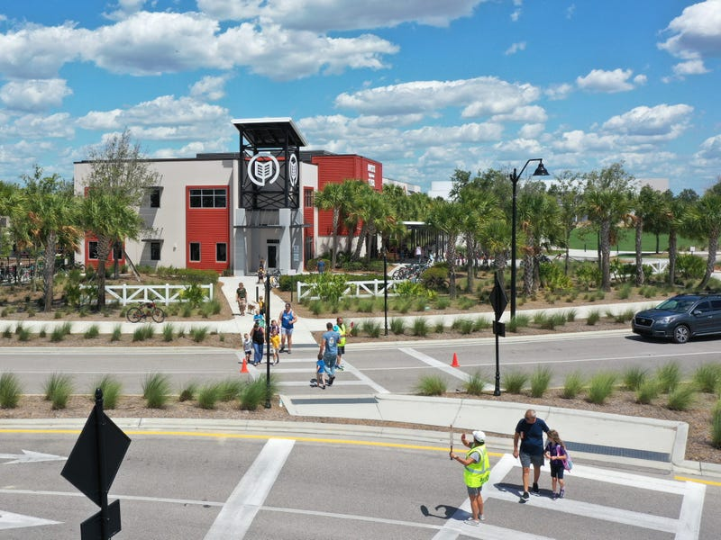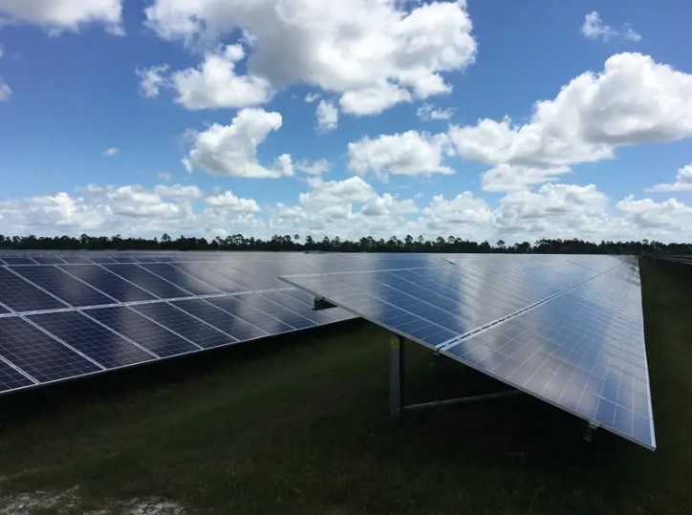
There are two schools in the town, Babcock Neighborhood School and Babcock High School, to accommodate the educational needs of the younger generation. Kitson & Partners
Any excess solar energy produced by the farm at Babcock Ranch goes back into the grid to serve other communities. Kitson & Partners

"We think other developers are now starting to understand that this is what people want and what people are looking for," he said. He said he's fielded calls from developers all over the country seeking to do the same thing that he did with Babcock Ranch.
"As a matter of fact, not only do I hope they copy what we're doing, but I hope they do it better," he added.

