Alternatives: | Where does it live? | What is the main cause of endangerment? | Is it helpful to environment?
Gray Bat
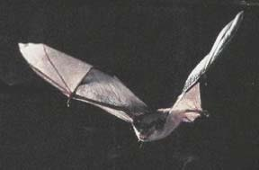
Reticulated Flatwoods Salamander
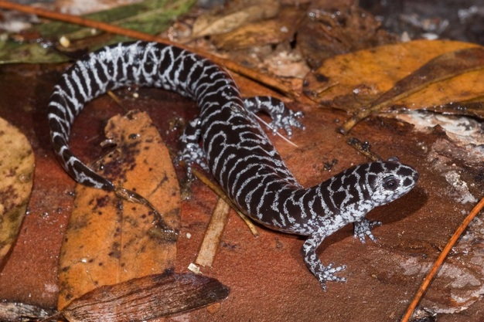
West Indian Manatee
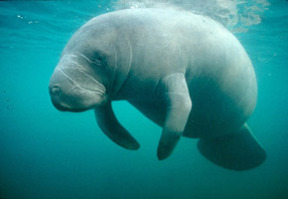
Florida Panther
