 | Criteria: Why are some locations good for recycling bins?
Alternatives: Different Locations | Easy to get to | Near where employees might have food or drinks | Opportunity for other community members to use the bin | Many people pass by it.
Near vending machines
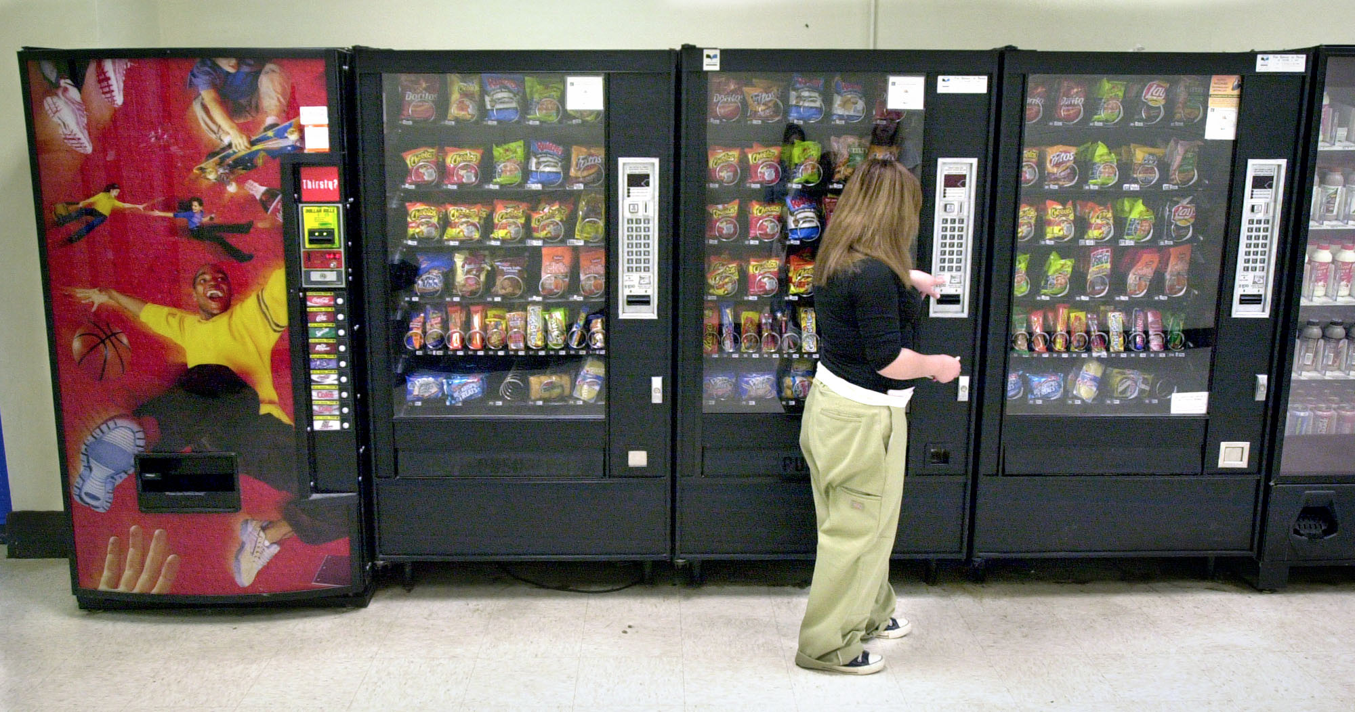
In employee parking lot
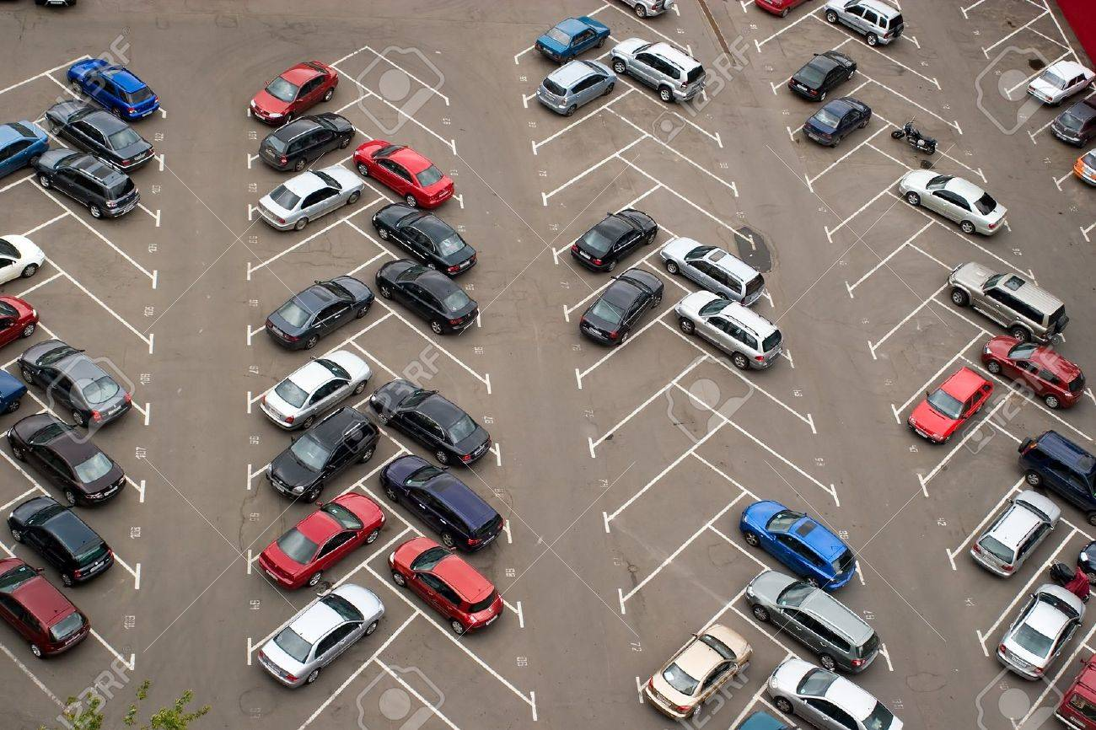
At the outdoor break area
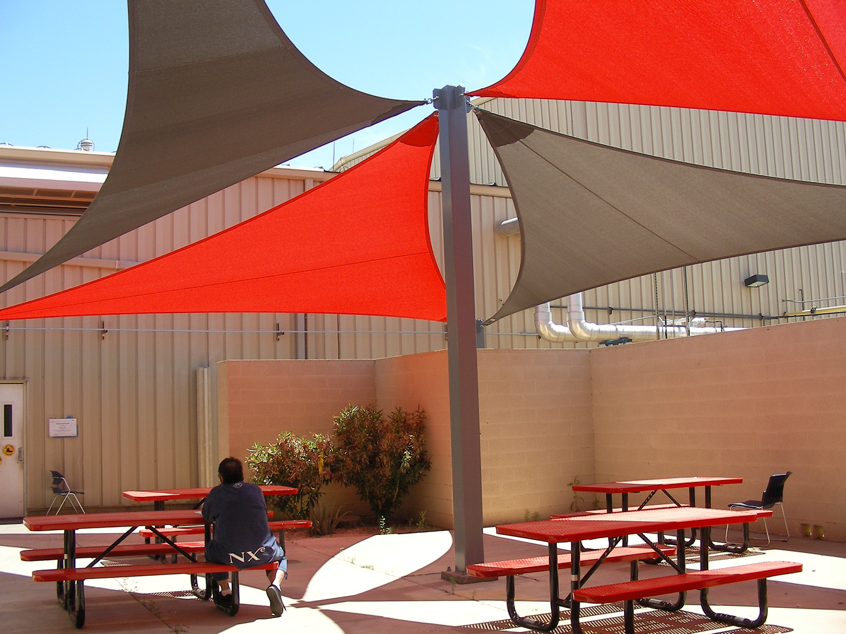
Outside the back door
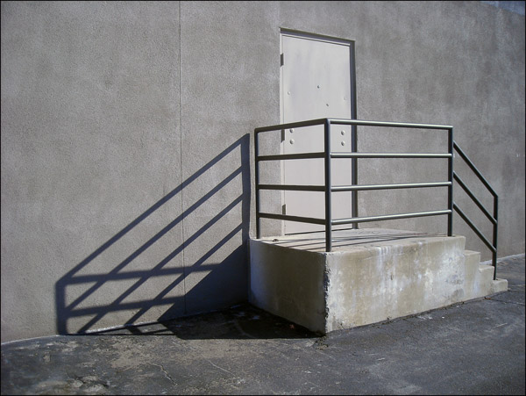
By the main entrance

