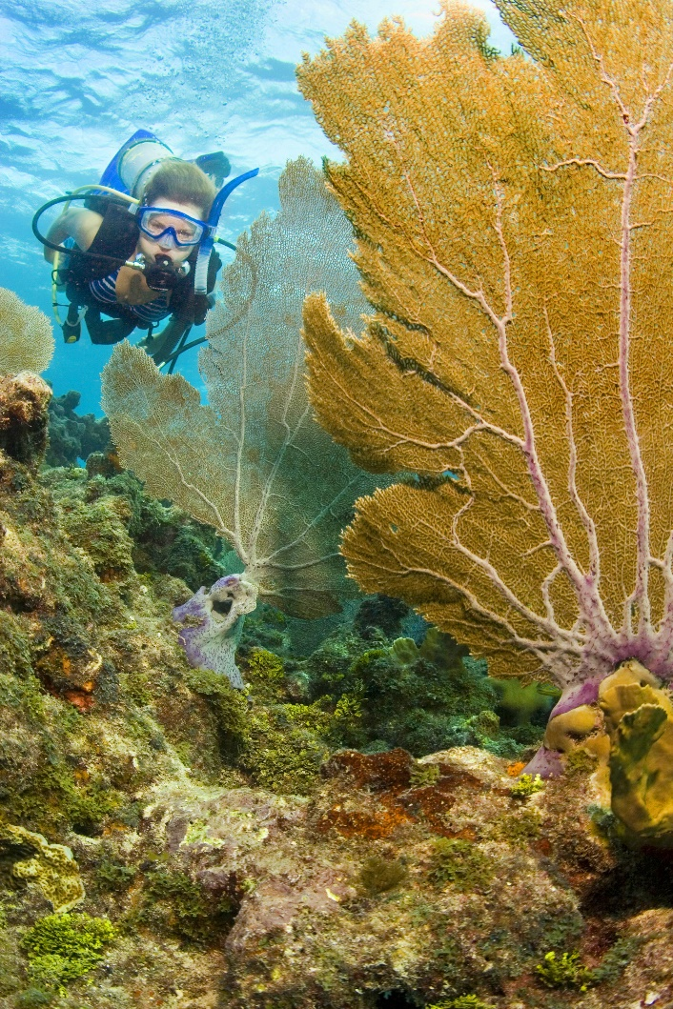
South Florida’s coral reefs are a natural wonder worth more than $6 billion to the local economy. For decades, there has been much concern as they have suffered damage, disease and deterioration. Now, at last, they appear to be rebounding.
The iconic reefs attract divers, boaters, marine scientists and fishermen from around the world. In recent years, they have been spared from major storms and ship groundings. This has allowed them to survive and even grow offshore.

South Florida's coral reefs rebounding Newsela

A federal study released this month brought more good news: Coral reefs may be able to adapt to warmer sea temperatures. That’s a sign they can withstand a limited degree of gradual global warming — but only if carbon emissions are restrained to prevent unhealthy extremes.
The findings raise hope for the survival of the recreational and economic resource. And the news comes just as scientists and officials gather in Fort Lauderdale, Fla., for the fifth annual Southeast Florida Regional Climate Leadership Summit. Attendees will discuss the costs and challenges of sea-level rise and global warming.

Reef Recovery
Florida is a low-lying state just above sea level and is home to 84 percent of the nation’s reef ecosystems. This makes it a perfect setting in which to examine the progress and problems of conservation.
“We haven’t had a large crash in the population of corals. And we have seen some good signs that the endangered species— staghorn coral — continues to be abundant and may even be increasing in abundance in some places,” said Richard Dodge, executive director of the National Coral Reef Institute. “So that’s the good news."
But, he added, “The bad news is: There are still some coral diseases out there. We still worry about bleaching, which appears to be caused by warmer water temperatures. But we are lucky in South Florida to avoid a lot of hurricanes and tropical storms lately. Those storms can wreak havoc on the reef.”
The reef recovery also has been helped by improved sewage systems, which prevent polluted water from seeping into the ocean. Greater public awareness has prompted boaters to avoid dropping anchors on the fragile reef. And a decision to move ship anchorages farther offshore from Port Everglades prevented damaging ship groundings.
Conservationists say the reefs also will benefit from Everglades restoration projects. These are designed to filter out pollutants rather than channel fertilizer-laden water out to sea.

"We Have Hit Bottom"
“People are aware they need to take better care of our coral reefs to help get them through what no doubt will be a stressful time, as the climate continues to change,” said conservationist Chris Bergh.
“We have hit bottom and are ever so slowly seeing some recovery,” he said. “There are a lot of big and expensive things that still need to be done, and I guess the most expensive of all is getting a handle on the root causes of climate change." And that essentially means, Bergh said, getting a handle on greenhouse gas emissions.
The recent study of Florida's reefs was conducted by the National Oceanic and Atmospheric Administration. It found indications that corals are able to adapt to gradually warming water temperatures. They will not be able to adapt, however, if carbon dioxide emissions push temperatures to extreme levels.
“It points to some hope, especially if emissions could be kept low,” Dodge said.
To help restore damaged reefs, scientists at the Reef Institute are growing baby corals in indoor nurseries. Once grown, they are transplanted offshore. Similar transplants are replenishing reefs along the Florida Keys.

The Northernmost Limit
Palm Beach and Martin counties are what Dodge calls “the tree line” of coral reefs. By this he means they are the northernmost limit of a semi-tropical ecosystem that supports a bounty of marine life.
The barrier reefs were formed over thousands of years when free-swimming coral larvae attached to submerged ridges in warm, shallow waters along the continental shelf. They cannot thrive in murky water because suspended sediments smother them, impair their feeding and deprive them of light.
The struggle to preserve them has turned into an economic as well as an environmental mission because of their impact on recreation and tourism.
Studies in 2000 and 2004 found that reefs along the southeastern Florida coast generated $6 billion of economic activity. They also supported 71,000 jobs.
“It’s probably a lot more than that by now,” said Jeff Torode, owner of the South Florida Diving Headquarters in Pompano Beach. “Without reefs, you don’t have fish. Without fish, you don’t have divers, you don’t have snorkelers." And without reefs "you don’t have something to protect those shorelines. For me to be in business, it’s in my best interest to protect the coral reefs.”

Tourist Magnet
Though eclipsed by other attractions, the reefs are a draw to tourists and their spending money.
“There’s no doubt that if we destroy those beautiful reefs, there will be some significant economic impact,” said Abraham Pizam, director of the Institute for Tourism Studies. “It’s an important element that should be preserved for generations to come.”
For South Florida promoters, the reefs are among the region’s biggest attractions.
“It is a very marketable identity when you can say to someone that we are the home of a strong coral reef community,” said Nicki Grossman, president of the Fort Lauderdale Convention & Visitors Bureau. “Dive boats have certainly taken advantage of our proximity. And it is a badge of honor to be a steward for reef systems offshore in greater Fort Lauderdale.”

