Climate change could bring stronger blizzards, scientists say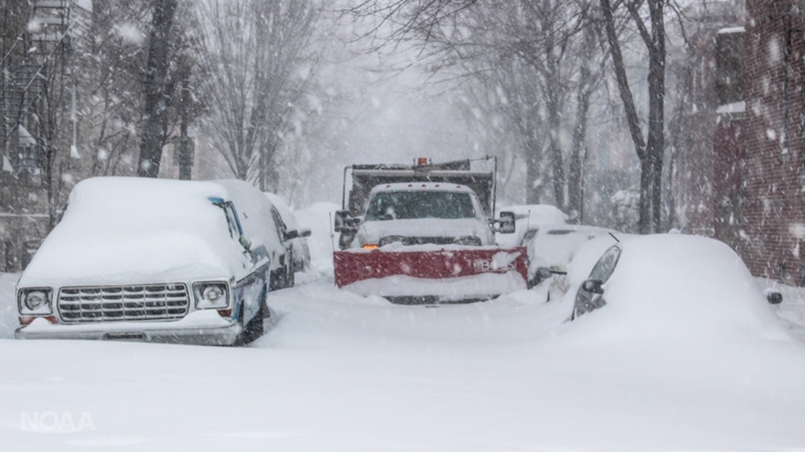A snowplow at work in the streets of Washington, D.C., during the January 2016 blizzard. Photo: John Flood/National Oceanic and Atmospheric Administration
By National Geographic Society, adapted by Newsela staff
RECOMMENDED FORUpper Elementary School – High School
WORDS452
TEXT LEVEL2
PUBLISHED1/29/2020
Main idea & themes
Key terms
Before reading activity
Discussion questions
Main Idea: The article is about how climate change is causing an increase in the intensity of blizzards and extreme winter weather events in the U.S. Northeast. Key Themes: * Climate Change * Extreme Weather Events * Jet Stream
These suggestions have been generated by an AI model, but the ideas and underlying gist are original and generated by a human author.
Copy
Report content
Zoom innatgeoed.org
Blizzards are strong winter storms. Snowfall is heavy and winds are strong. They can be dangerous. Sometimes, you cannot see very well.
There have been many strong blizzards in the last few years. They have hit the East Coast of the United States. One was so bad it was called "Snowzilla."

Humans Contribute To Climate Change
Weather is the day-to-day events in the atmosphere. It is the forecast for clouds and rain one day, and a sunny day the next. Blizzards are part of the weather. But they are affected by climate change.
Climate change is the average weather of an area. It keeps track of 30 years of weather. Climate change is caused by humans. The gases, coal and oil we burn release carbon dioxide. It is a greenhouse gas. The Earth needs it to stay warm. But too much carbon dioxide is making the Earth too hot. The temperature of the Earth is going up.
Scientists say that climate change makes blizzards stronger. There is more water in the air when it is warm. More moisture goes into the air when the seas get warmer. This moisture falls back to Earth. It is the rain and snow.
All of this moisture makes storms stronger. It also makes them happen more. This makes blizzards stronger. They happen where it still gets cold.

Changing Climate Conditions
Climate change affects ice and glaciers. Sea ice reflects sunlight. But the ice is melting in the Arctic. Now, the sunlight warms up the ocean. The hot seas make the ice melt more. It makes the Arctic warm up faster than other places. It also changes the weather in other parts of the world. Snow reflects sunlight. Less snow means more water. Dark ocean water absorbs sunlight. Water becomes warmer. More ice melts. This changes weather patterns in other parts of the world. It can cause severe winter weather.
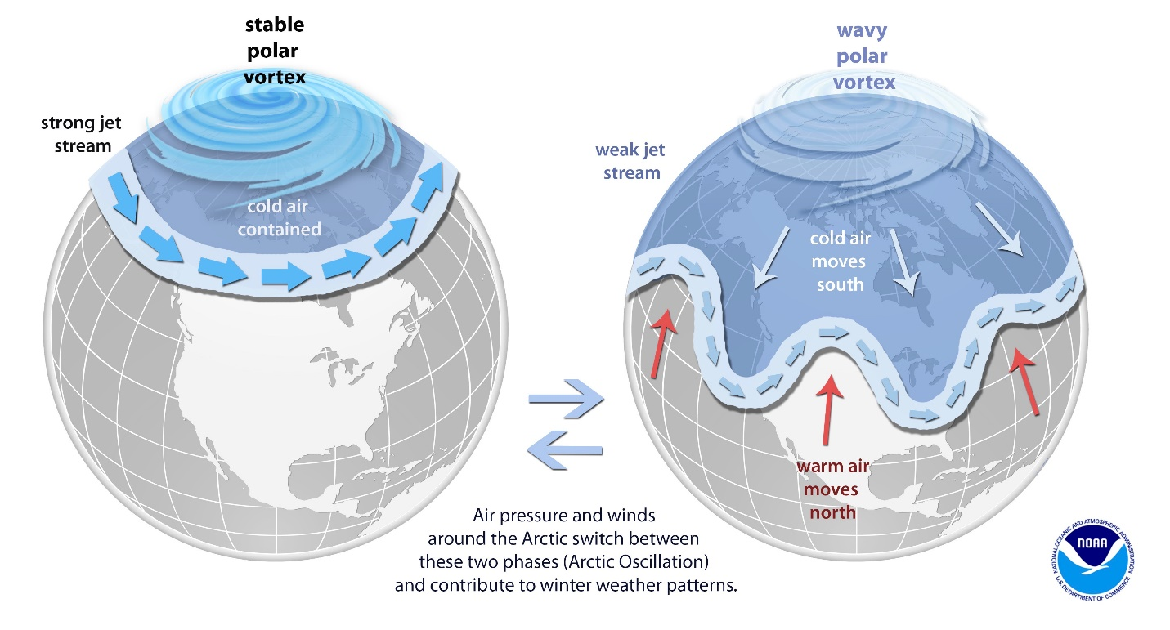
Zoom inThe jet stream circles the atmosphere in a fast and straight current. When the temperatures to the north and south of the stream are too similar, the stream becomes wavy. This pulls cold air from the polar vortex south. Blizzards and polar vortex storms happen. Photo: National Oceanic and Atmospheric Administration
We can see the effect of global warming on the atmosphere. The jet stream is a fast-moving flow of air. It moves in the lowest region of the atmosphere. The stream moves fast when it is cold in the north and warm to the south. The warming Arctic makes the stream move slower. It stops moving in a straight path. It weaves north and south. This pulls Arctic air down from the north. Blizzards happen easily. So do polar vortex storms.
Provided in partnership with the National Geographic Society. Visit this article and find others like it on National Geographic's site at: https://www.nationalgeographic.org/education/

