 | Criteria:
Alternatives: Different Sea Turtles | To what extent is it at-risk ? | Who is its predators? | How long does it live? | Why is it in trouble?
Green Sea Turtle
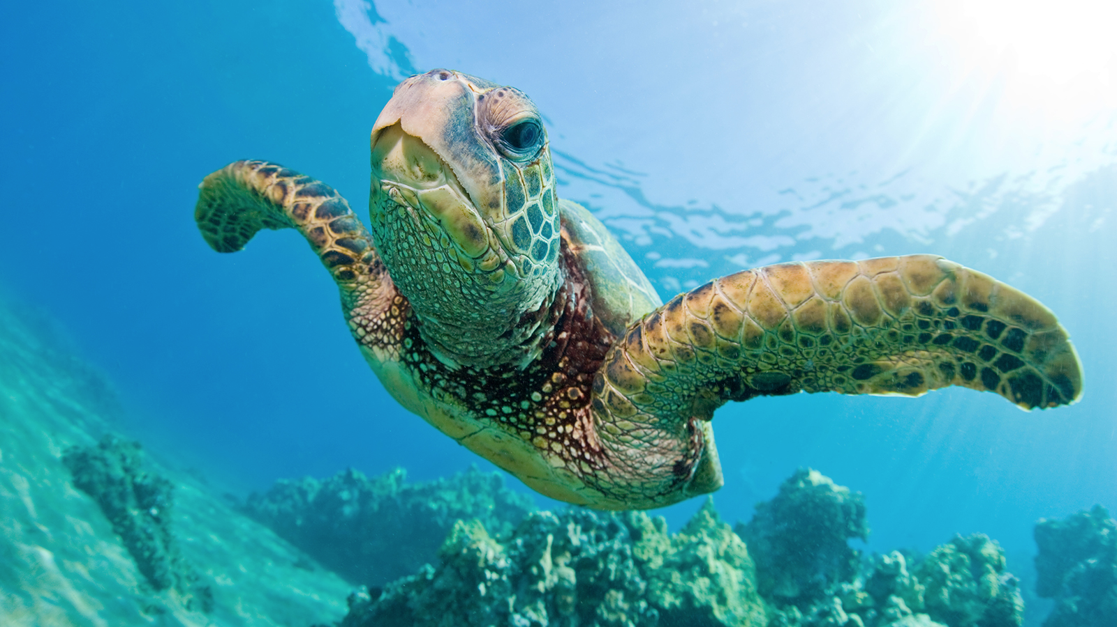
Leatherback Sea Turtle
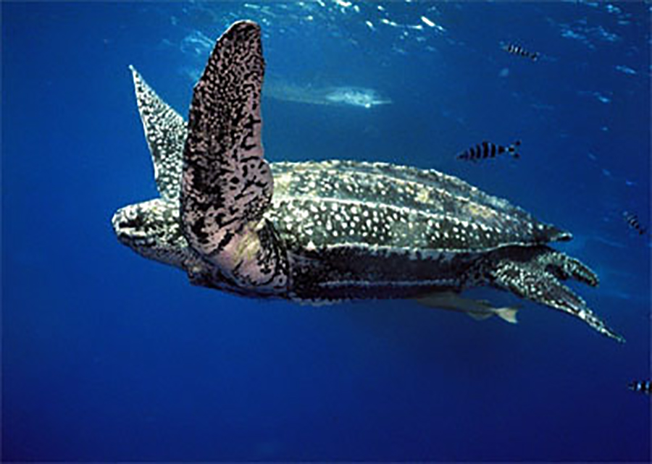
Loggerhead Sea Turtle
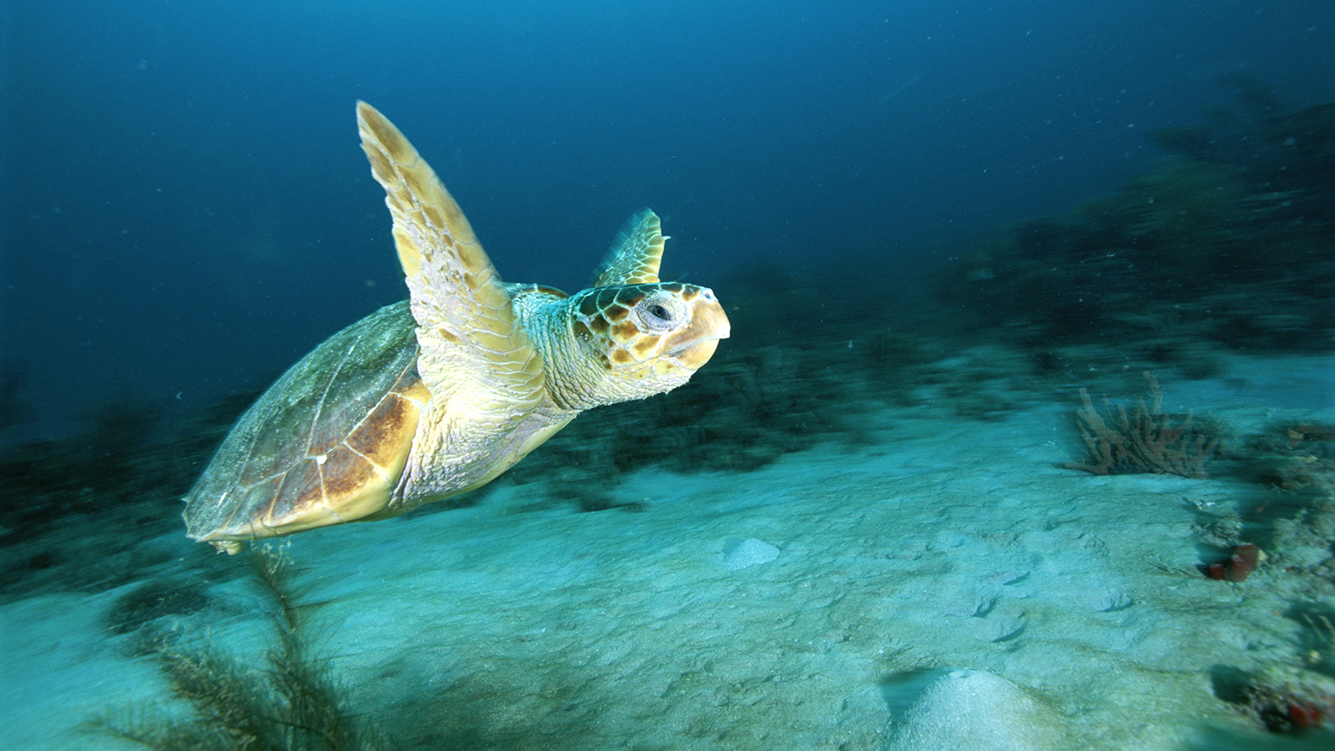
Hawksbill Sea Turtle
