New York Post
Beachgoers left 12,000 Pounds of Trash on Reopened Florida Beach
By Priscilla DeGregory May 12, 2020

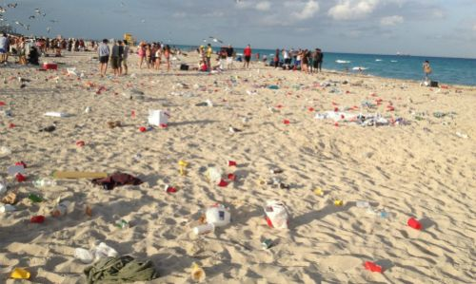
Sunbathers at a Florida beach left behind 12,000 pounds of trash on the first weekend the beach was reopened after coronavirus closures, prompting local police to crack down, according to a report.
The nonprofit organization Keep Brevard Beach Beautiful (KBBB) collected 297 bags of trash left behind by beachgoers in Cocoa Beach, on Florida’s east coast, after the city’s beaches reopened the first weekend of May, according to a CNN report.
The bags can hold around 40 pounds each, which means there was some 12,000 pounds of garbage collected, the Florida-based nonprofit said.
But the real figure could be even higher as chairs, tents and umbrellas were also abandoned, KBBB executive director Bryan Bobbitt told CNN.
On the second weekend of May, the organization collected another 305 bags of trash. On average, crews collect 30 to 40 bags a day during this time of year, Bobbitt said.
“The numbers we are seeing right now rival Memorial Day and Fourth of July weekend,” he told the outlet, adding that his crews also empty trash cans around three times a day.
Bobbitt worries that this deluge of rubbish, both from heaping trash cans and items left on the sand, could harm animals.
“When we see something that can be a choking hazard to marine life, we make it a point to get that stuff as well,” he said.
“We’ve all seen the photo of the straw stuck in a sea turtle’s nose or a six-pack ring around a bird’s neck.”
The Cocoa Beach Police Department responded to the uptick of trash, warning of $250 fines for littering — a law put in place before the pandemic.
“As restrictions are becoming more relaxed during this pandemic, the City of Cocoa Beach is beginning to see an influx of day-trippers to our beaches, along with piles of unlawfully discarded trash in their wake,” the PD’s post said. “This will not be tolerated.”
The department sent out additional officers — both uniformed and undercover — this past weekend as some 10,000 people visited the beach, Cocoa Beach Detective Sgt. Thomas Cooper told CNN.
But the cops were only able to issue one citation as it’s challenging to catch someone in the act of littering, Cooper told the outlet.

