Ozone layer 'on track to recovery': Shield that protects Earth from sun's rays is slowing repairing itself, UN scientists reveal
- Gaping hole in ozone which in 1980s caused a major environmental scare
- UN scientists have found that it has now stopped growing
- Hole in ozone layer will start shrinking in about a decade, they hope
By BEN SPENCER FOR THE DAILY MAIL
PUBLISHED: 04:03 EDT, 12 September 2014 | UPDATED: 07:29 EDT, 12 September 2014
The ozone layer that shields the Earth from the sun is showing the first signs of recovery, UN scientists have revealed.
The gaping hole in the ozone layer above Antarctica – which in the 1980s caused a major environmental scare – has stopped growing, they have found.
And other damage to the ozone layer is ‘well on track’ to recovery and may have even been reversed by 2050, according the United Nations Environment Programme and the World Meteorological Organization.
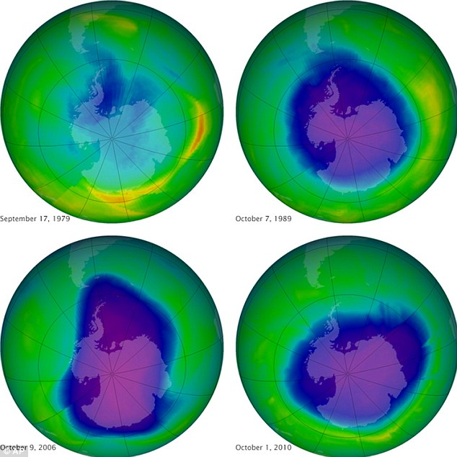
Earth's protective but fragile ozone layer is finally starting to rebound, says a United Nations panel of scientists. Scientists hail this as rare environmental good news, demonstrating that when the world comes together it can stop a brewing ecological crisis. Here the shifting size of the ozone hole is illustrated in a dark blue
Ozone forms a ‘screen’ in the upper levels of the atmosphere which absorbs damaging solar rays.
Evidence emerged 30 years ago that ozone was being severely depleted by man-made gases, such as the CFCs used in fridges.
It caused a huge health scare, especially in southern-hemisphere countries such as Australia and New Zealand, which are situated close to the massive hole in the ozone layer above Antarctica.
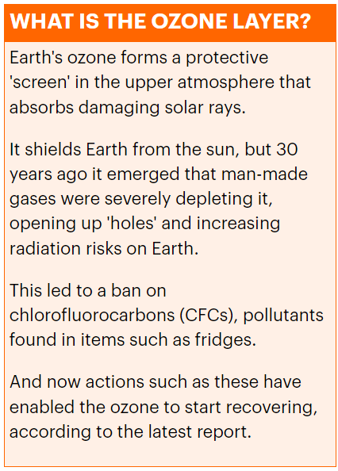
Experts predicted that the reduced screening from UV rays would lead to soaring rates of skin cancer.
The scare led to a 1987 ban on CFC gases in fridges and aerosols – an action that the UN said is responsible for the ozone recovery and has saved 2 million a year from skin cancer.
WMO Secretary-General Michel Jarraud said: ‘International action on the ozone layer is a major environmental success story.’
The hole in the ozone layer will start shrinking in about a decade, scientists hope.
WMO senior scientific officer Geir Braathen added: ‘Now for the first time in this report we say that we see indications of a small increase in total ozone. That means recovery of the ozone layer in terms of total ozone has just started.
'We think in about 2025 or thereabouts we’ll be able to say with certainty that the ozone hole is getting smaller.’
Professor David Vaughan from the British Antarctic Survey said that test results from his organisation would throw extra light on the WMO’s findings.
‘We have to be a bit cautious, but this does look on the face of it like some very good news,’ he said. ‘Our own data from the Antarctic will take a few weeks to process but we hope to confirm the findings. If it’s accurate, it underlines the potential power of international agreement.’
Achim Steiner, UNEP’s executive director, used the success of the international protocol to call for a similar international deal on climate change.
David Cameron announced this week he will travel to New York on September 23 for an international summit on climate change. Barack Obama has also agreed to attend – but the ability of the conference to see meaningful agreements has been undermined by news that the leaders of Germany, China and India will not be there.
