Human Impact Data Set 1

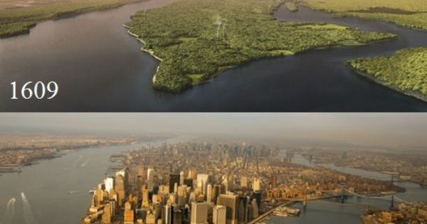

Present Day

**The picture above is of Manhattan, NY before and after human impact**

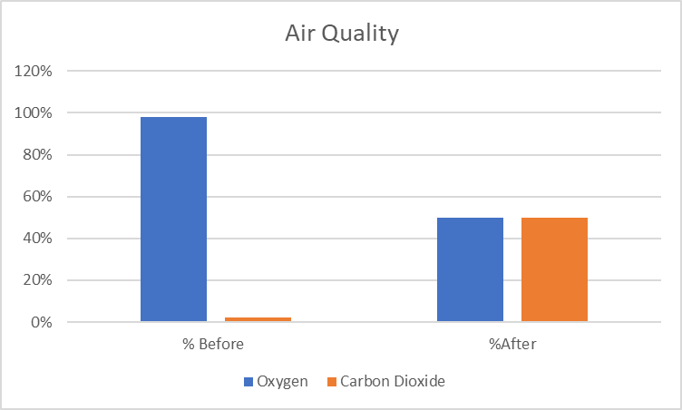 Human Impact Data Set 2

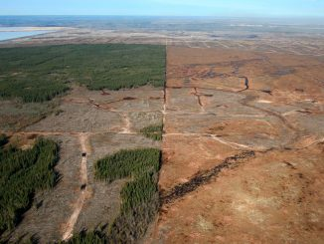

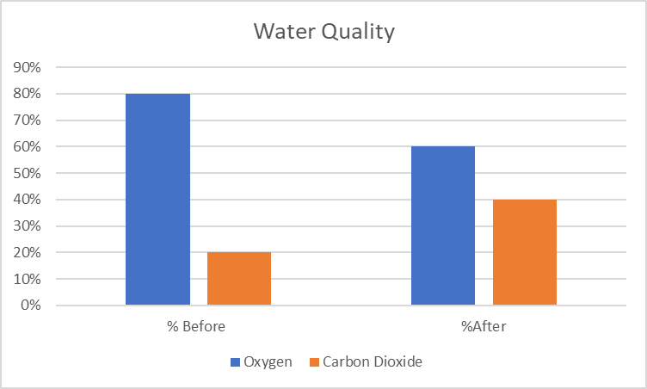

Present Day

1900

**The picture above is a before and after photo of a forested area turned farmland**

Organism Population After Human Impact

NO DATA TO REPORT, LAND IS BARREN, NO ORGANISMS HAVE BEEN RECORDED

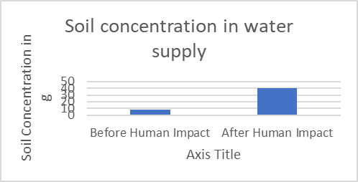

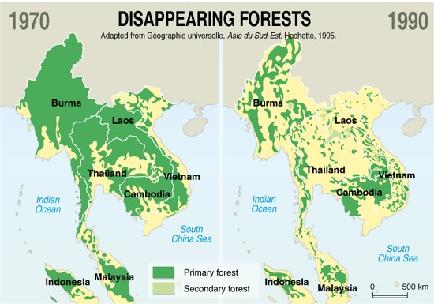Human Impact Data Set 3

