Oh Goodie!

Students will interpret data using the table provided listing the
different items and their results.
Items: | Size:  (very small- very large) | Popularity  Number of students | Student  Comments
Jelly beans | Very small | 5 | 10 students suggested lollipops instead
pencils | medium | 12 | 9 students liked the idea for pencils and suggested erasers
bubbles | large | 17 | 2 students suggested that bubbles were messy
Yo-yo | small | 18 | 17 students liked the idea
Water bottle | Very large | 8 | 5 students suggested juice pouch instead

Dear Students,
I need your help in planning a surprise birthday party for Mrs. Serra our Spanish teacher. We will be creating “goodie bags” for all of the guests attending the party. We need to keep in mind that since we are departmentalized, there will be a total of 36 students participating in addition to our two homeroom teachers and Mrs. Serra. I need to know what kinds of item you would like to include inside the “goodie bags”. In the next page, I have listed some of the ideas for the items that we could include so that we can tally the votes and make the best choices due to popularity. I have provided a chart with a few of the choices made from students in the past.
Please write a letter back to me explaining how you decided which items were the best to include inside of the “goodie bags” and your reasoning behind why your group chose those items. Thank you for your help in making this a wonderful surprise party!
Sincerely,
Ms. Lopez

Dear students,

Which Brand of Chocolate Chip Cookie Would You Buy?

Are you looking for a job that allows you to combine the mathematics, science, language arts, writing, and communications skills you have worked so hard to acquire? Are you creative? Do you enjoy working with data? Do you like chocolate chip cookies? If so, my company may have the job for you!
We are an up and coming advertising firm who has been hired to market several brands of chocolate chip cookies. Each brand has its own unique features and at this time, the manufacturers have provided us with the mean thicknesses, diameters, masses, and number of chocolate chips for each cookie. We realize that you are being provided with a limited amount of data but we are confident that you will be able to visualize a variety of real-world implications. Our company prides itself on originality and honesty so it is up to your group to analyze the data that has been provided to you and find a creative way to rank and then market the brand of your choosing. Please provide us, in writing, with your data analysis, a description of the process you used to determine which cookie brand to market, and a description of how you would market that brand.
Once we have received all of your entries, our company will choose the campaign which we feel will best meets our needs and offer the group who designed that campaign a contract with our firm. We look forward to evaluating each of your ideas. Good luck to all of you!

Yours Truly,
Chip Baker
President Baked Goods Marketing

Table 1: Measurements Acquired based on 1 cookie for each brand
Cookie Brand | Mean Diameter (cm) | Mean Thickness (cm) | Mean # of chocolate chips | Mean Mass (g) | # of cookies per package | Suggested Retail Cost of a package of cookies
A | 5.4 | 0.85 | 25 | 12.6 | 36 | $3.59
B | 5.2 | 1.10 | 17 | 14.2 | 32 | $2.99
C | 5.0 | 1.00 | 20 | 18.9 | 24 | $1.99
D | 5.8 | 0.8 | 18 | 16.2 | 28 | $2.49
Table 2: Measurements Calculated based on 1 cookie for each brand (to be completed by students)
Cookie Brand | Average Area  (cm²) | Average Volume  (cm³) | Average Density  (g/ cm³) | Average retail cost ($/cookie)
A
B
C
D
Table 3: Taste Test Results (Based on a survey of 100,000 random consumers; rating ranged from 0 to 10, with 0 representing the worst taste and 10 representing the best taste)
Cookie Brand | Taste Rating
A | 8
B | 7
C | 4
D | 6
Cookies and Treats
Cookies and Treats prides itself in making the best baked goods in Plantation, Florida. Our customers line up around the corner each day waiting for us to open our doors. We are in the process of picking new packaging for our cookies. We would like to have two kinds of packaging, one a bag for smaller cookie orders and the other a box for larger cookie orders.
We need your help deciding which packages to purchase and how many. We typically buy enough supplies for one business quarter, which is 13 weeks-long. Keep in mind, our shop is open 6 days a week! Based on our sales reports, we will need to buy enough small packaging for an average of 110 cookies each day with an average sale of about 3 cookies per small order. We will also need to buy enough large packaging for an average of 142 cookies each day, with an average sale of about 9 cookies per large order. We would also like you to read the letter from Boxes ‘n’ Stuff and organize all the important information into a data table. This will help us understand the data better as you are explaining your recommendations for which packaging we should buy.
As a team, develop a procedure for selecting the best packaging options for us. Then, write us a letter describing your procedure for ranking the packaging materials. Let us know your top choice for which bag and which box we should buy, as well as your ranking for all the packaging options. Please also include your recommendation for how many of each type of package we should purchase for the next business quarter. Be sure to explain how your team made your decisions and describe the process you went through for selecting the packaging and determining the supply order. We hope to hear from you very soon! Cookies and Treats needs your help!
Use this information to create a data table:
We offer 4 small bag choices. Bag Option A is a brown paper bag on which we can place your logo. This bag option sells for $0.19 per bag and can hold up to 4 cookies. Bag Option B is made out of plastic film. It is clear so it makes it easy for the customer to see what they are getting, but we cannot place your logo on this option. Bag B sells for $0.10 per bag and can hold up to 2 cookies. Bag Option C is made out of cardboard and looks similar to a carton of French fries you might get a fast-food restaurant. It is white, very sturdy, and we can place your logo on it. Bag C costs $0.25 per bag and can hold up to 4 cookies. Bag Option D is our newest edition! It is an aluminum foil bag that can hold up to 3 cookies. We cannot print your logo on this type of bag because the ink will not stick to the foil, but your cookies will stay fresher longer. Bag D normally costs $0.30 per bag but it is currently on sale for $0.27 per bag.
You also asked for boxes that can hold larger cookie orders. We have three such boxes to choose from. Two of the boxes are in the shape of a cube and the other is in the shape of a cylinder. All of our boxes are a standard size and will hold up to ten cookies. Box Option A is made of sturdy cardboard and is very easy to assemble. It is white in color and we can place your logo on it. Box A is priced at $0.53 per box. Box Option B is made of a sturdy white plastic material but includes a clear window made of plastic film at the top of the box so that your customers can see what is inside. However, due to the plastic film at the top of the box we cannot include your logo. Box B costs $0.68 per box. Box Option C is a cylinder. It is made of sturdy cardboard. You can choose whatever color you would like the box to be and we can place your logo on in. Box C is priced at $0.71 per box.

Shopping Bag  It’s in the Bag | Information to Consider
Paper bags | In 2012, 65.1 percent of paper used in the U.S. was recovered for recycling.  - Paper bags help reduce greenhouse gases in the atmosphere by requiring less energy to produce.  - Every ton of paper that is recovered for recycling saves 3.3 cubic yards of landfill space.  - The recovery rate for paper bags is four times greater than that of plastic bags.  - In 1999, 14 million trees were cut to produce the 10 billion paper grocery bags used by Americans that year alone  - Paper bags use 84 times as much energy to recycle compared to a plastic bag  - Paper bags help reduce greenhouse gases in the atmosphere by requiring less energy to produce  - Paper bags are made from trees, a renewable resource  Impact on Florida’s marine life:  Life cycle analyses show a higher level of environmental harm from manufacturing to disposal of paper compared to plastic bags
Reusable Bags | Ideally, your reusable bag would be large enough to fit 5 times the groceries that a plastic bag would hold, similar to what a paper bag would hold.  - Durable and you can continue to reuse it for 2 - 3 years without needing to replace it.  - If not washed, the bag may accumulate microorganisms that could seep into the food cause illness.  Can cost as much as a few dollars each
P\Plastic bags | - Low cost  - Ease of Use  - More durable than paper bags  - They are manufactured from petroleum, a non-renewable resource  - Plastic shopping bags give off lower levels of greenhouse gas and waste.  - Low recycling percentage  - Un-recycled plastic bags generally find their way into local landfills.  - Plastic bags are capable of being melted and can subsequently be remolded in such things as plastic lumber, which can be used on park benches and fencing material.  - The manufacture of plastic bags leads to a net increase of carbon dioxide in the atmosphere.  Impact on Florida’s marine life:  We're treating the oceans like a trash bin; around 80 percent of marine litter originates on land, and most of that is plastic.  Plastic that pollutes our oceans and waterways has a severe impact on wildlife. Seabirds, whales, sea turtles, and other marine life are eating marine plastic pollution and dying from choking, intestinal blockage and starvation.
Company | Voice cost (per minute)  over 200 minutes | Monthly charge for unlimited text and 300 voice minutes  (Includes tax) | Other Notes  Choose Voice Cost or Monthly.
Bro Phones | $. 15 | $19.99 | Free phone with one year contract  Camera  Internet
Talktome | $. 10 | $14.99 | Free phone with two year contract  Camera  Internet  Short battery life  Eco-friendly company
Genius Phones | $. 20 | $29.99 | $ 3.00 of every phone donated to fight world hunger  Free phone  No contract needed/Pay as you go  Camera  Internet  Eco-friendly company
Anydroid | $ .10 | $34.95 | $ 5.00 of every phone purchased is donated to fight world hunger  Free phone  No contract needed/Pay as you go  Camera  Internet  Long battery life  Parental blocks  Rated top 10 in Consumer Review
Ispy | $ .10 | $34.99 | Free phone  No contract needed/Pay as you go  Camera  Internet  Some customer complaints about  Can track you from any cell phone

Hello,
I want a cell phone
My company is targeting cell phone companies with a new idea for selling. We want to convince parents that cell phones are necessary for elementary school students. I need for your team to come up with a procedure that will help me select the best cell phone to convince parents that having a cell phone is necessary.
All of the information your team will need is located on the next page. You will need to calculate the cost of each plan and make a list of the pros and cons of purchasing each phone. Please write a letter to me explaining your team’s procedure to decide which phone plan we will buy. Include information that tells me how you came up with your decision and describe your process.
I look forward to hearing from you soon! I really appreciate your help.
Thank you,
Ms. Iam Smart
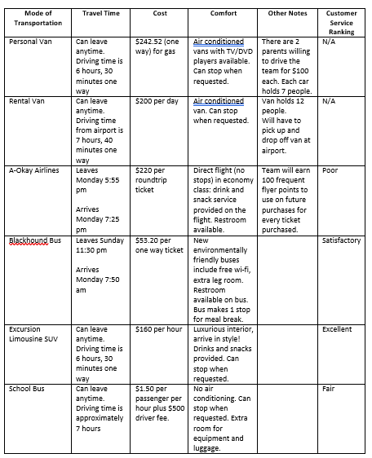

Transportation Choices

Dear Engineers,
As the coach of the Red Rockets baseball team, I believe in hard work and determination. Well, our hard work has paid off! Recently 10 members of my team and I were invited to travel around the country to hold camps for students. We will be responsible for teaching students the skills they need to be as good as us!
First, we will be travelling to Atlanta Georgia. The total travel time is 5 days (leaving on a Monday, returning on a Friday). We need to know what mode of transportation is best. Attached, please find a data table showing the mode of transportation, cost, time, comfort, and availability. Send an email to your teacher who will forward it to me letting me know the ranking of the options from best to worst. Include a detailed description of your procedure for choosing which mode of transportation is best for us so I can share it with my team.
Thank you,
Coach

Cheesy Pizza Delivery: I Need a New Car
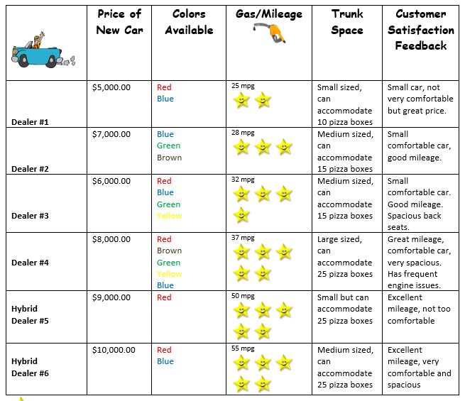

Dear Engineering Team,
I own a pizza delivery company and I must replace all the cars we use for delivery. I need your teams help in choosing the right one. I have a list of several car dealers, the price of each car, the colors and gas mileage, and lastly, the size of their trunk space for the car selected. I am having a hard time with the data and need your help to come up with a way to rank them. I have also included customer satisfaction data that provides feedback on each vehicle.
I will give you the information on the next page and hope that you can write a letter to me that explains the ranking of the cars. Can you also include information that tells me how you came up with your decision and describe your process.
We want to ensure we maintain our reputation for timely delivery, so please hurry.

