Coral reefs prepare for warmer waters
NewsELA
The Persian Gulf's coral reefs are not the biggest. They are not the prettiest, either. They do not even have as many plants and animals as some other reefs. But they have become a favorite spot for scientists to study.

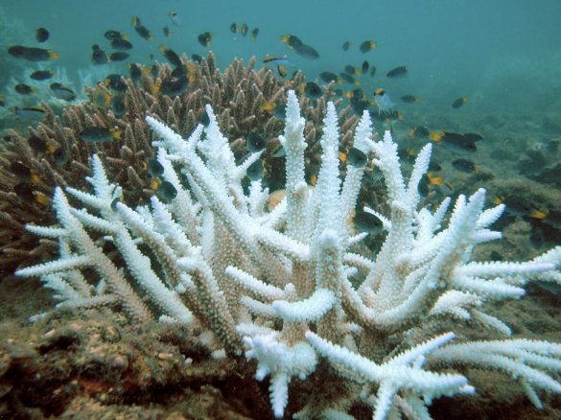
The water in this area is very warm. Persian Gulf corals can handle water that is up to 36 degrees Celsius (97 degrees Fahrenheit). Other coral reefs can only handle water as warm as 29 degrees C (84 degrees F).
It might only sound like a few degrees difference, but it's a big deal for the corals. If the water gets too warm, the corals will "bleach." They will turn white. It happens when they let go of all the tiny organisms that live inside them. These tiny organisms are called algae.

Coral And Algae Work Together
Corals live together with the algae. They need each other. Coral needs algae for food. Without algae, corals can get sick. They are also more likely to die.
John Burt is a marine biologist. That is a special kind of scientist. He only studies things that are under water.
Burt has been studying the Persian Gulf corals for the last three years. He is excited about what he has learned. He wants to use this new information to help reefs in other areas.
Burt did not work alone in the Persian Gulf. He worked with scientists from all over the world. They want to help coral in other places. Together, they discovered a new kind of algae that only grows in the Persian Gulf.
Burt and his team believe the new algae is what makes the Persian Gulf corals so much better at living in warm water. They want to use the new algae to help other corals. They think they can prepare other reefs for warmer water. It could protect them from bleaching.

Many Things Have Hurt Reefs
Coral reefs have been in danger for many years. Humans have hurt the reefs. Pollution and too much fishing has damaged coral reefs. Some reefs are only half the size they used to be.
Still, most scientists say that heat is the biggest problem for the reefs. The Earth is getting warmer all the time. That is why scientists want to make sure the coral reefs are ready for warmer water.
The scientists want to move some algae to other reefs to protect them. First, the scientists want to answer many questions. They want to find out how the algae got to the Persian Gulf. They need to learn more about what makes it so strong. They also want to make sure it will not hurt the other reefs.

Answers Could Be In Cooler Waters
Some scientists are not as excited as Burt and his team are. They do not think just moving algae could fix such a big problem. They also say the Persian Gulf corals are too different from other reefs. They do not think the algae will work in other areas.
These scientists say Burt and his team should spend their time looking for answers in cooler waters. They have suggested the reefs between Tanzania and Madagascar. The corals there have been through very bad bleaching events. They are much healthier now.
Burt and his team have listened to the other scientists. They are still excited about the Persian Gulf algae. They know that finding a solution will take a lot more work. They still want to keep looking for ways to use the new algae to help coral in other places.

Reproduced with permission. Copyright © 2023 Scientific American, a division of Nature America, Inc. All rights reserved.

