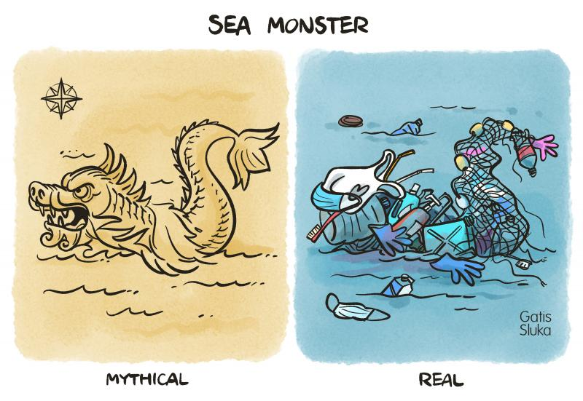
tps://cartoonmovement.com/cartoon/sea-monster
Gatis Sluka
19 August 2020

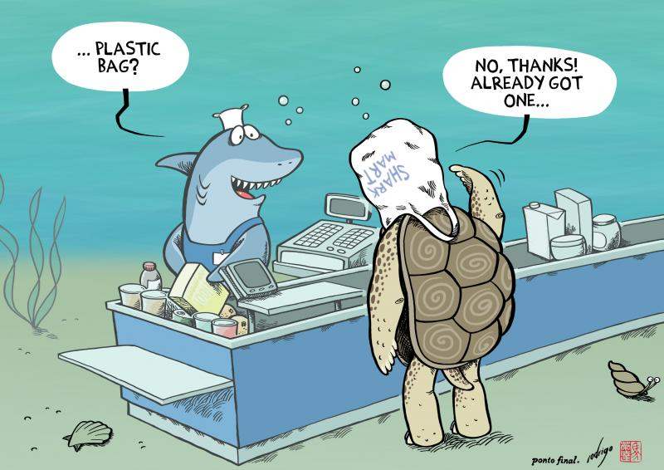

https://cartoonmovement.com/cartoon/plastific-ocean
Rodrigo de Matos
14 June 2021

https://theweek.com/cartoons/776928/political-cartoon-world-environment-climate-change-sea-levels-trash-plastic-pollution-ocean

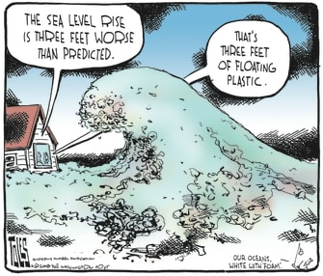

https://conservationbytes.com/2018/10/23/cartoon-guide-to-biodiversity-loss-li/

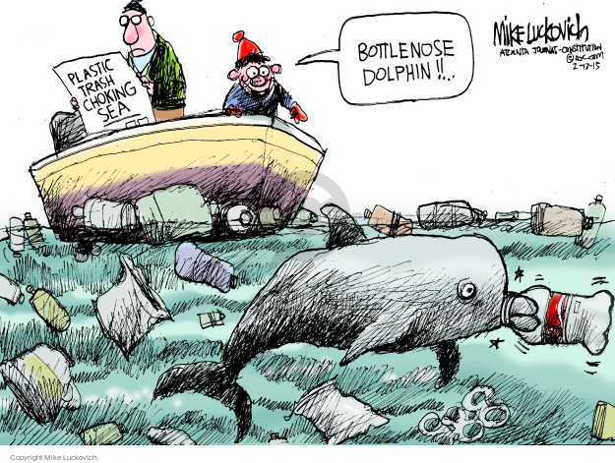

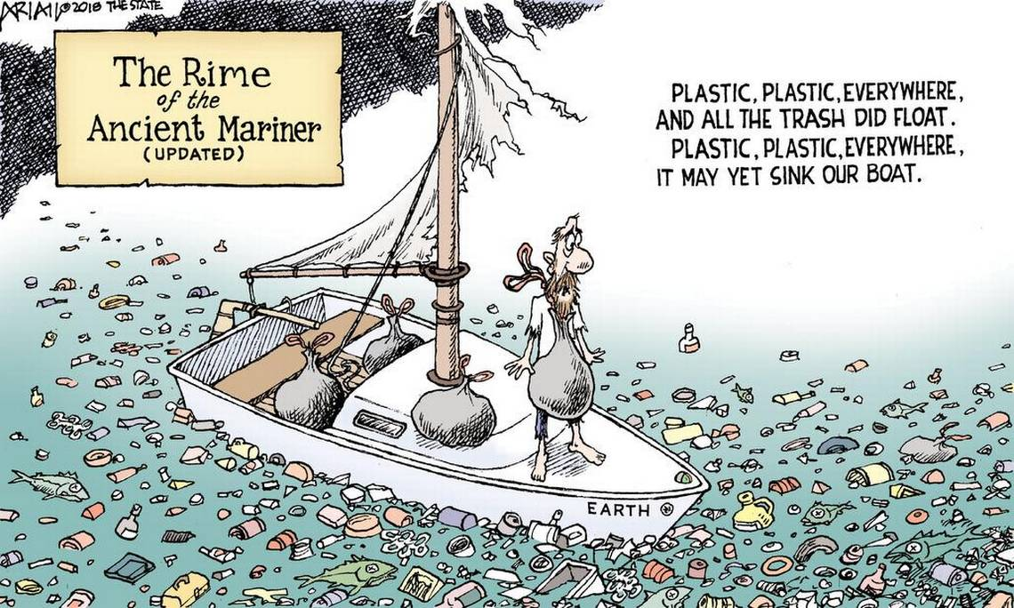

www.theslate.com

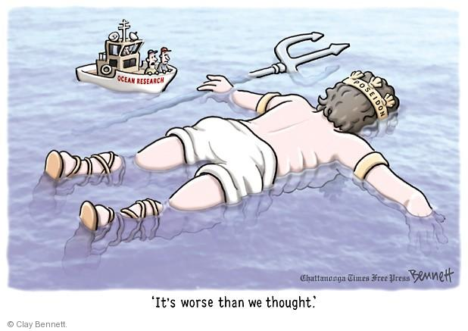
https://www.cartoonistgroup.com/subject/The-Ocean+Pollution-Comics-and-Cartoons-by-Clay+Bennett%27s+Editorial+Cartoons.php

