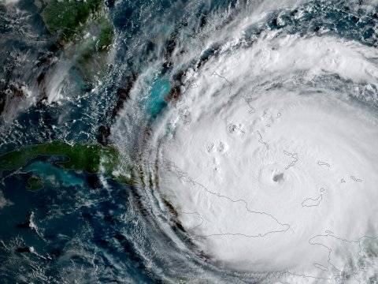
Hurricane Support Society and The Lorax
Placing Resources Where They Are Needed Most

Wanted: Research Teams!!

The Hurricane Support Society is sending volunteers to areas in Florida that were impacted by Hurricane Irma. At this time, the Society has funding to send volunteers to one Florida Location. These locations are:

Key West
Miami
Everglades National Park

We need research teams to help us decide where we should place our resources first. All of these areas have been impacted in one or more of the following ways:

Ecosystems
Families
Tourism
Local Economy

If your team is interested in supporting victims of Hurricane Irma, please contact the society with the three locations ranked in order of need. Explain how you made your decisions.

Thank you for helping your fellow citizens!

Hurricane Support Society
Follow us on

