Alternatives: Different Sea Turtles
Green Sea Turtle
Leatherback Sea Turtle
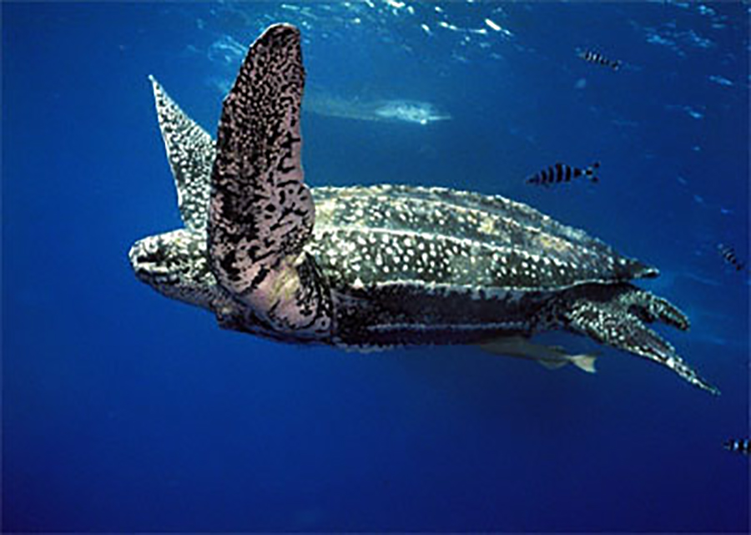
Loggerhead Sea Turtle
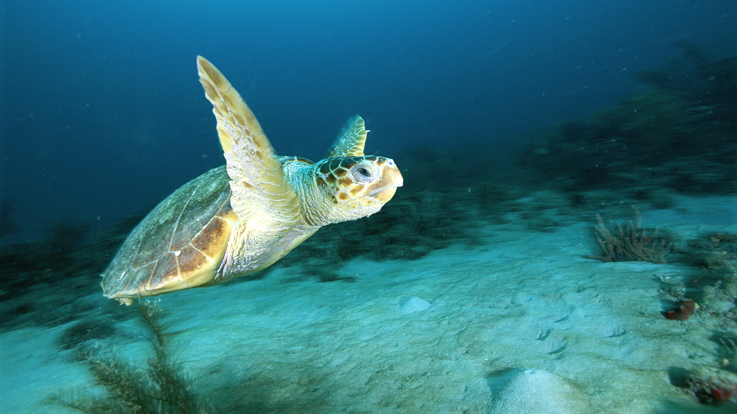
Hawksbill Sea Turtle
